National provisions regarding the requirements for grid connection of generators established by Elering AS pursuant to Article 7(4) of Commission Regulation No 2016/631

Approved with Competition Authority Resolution No 7-26/2018-005 of 8 November 2018

Applied as of 27 April 2019

Article 5 Determination of significance

Power-generating modules within the following categories shall be considered as significant: (a) connection point below 110 kV and maximum capacity of 0,8 kW or more (type A);
(b) connection point below 110 kV and maximum capacity at or above a threshold proposed by each relevant TSO in accordance with the procedure laid out in paragraph 3 (type B). This threshold shall not be above the limits for type B power-generating modules contained in Table 1;
(c) connection point below 110 kV and maximum capacity at or above a threshold specified by each relevant TSO in accordance with paragraph 3 (type C). This threshold shall not be above the limits for type C power-generating modules contained in Table 1; or
(d) connection point at 110 kV or above (type D). A power-generating module is also of type D if its connection point is below 110 kV and its maximum capacity is at or above a threshold specified in accordance with paragraph 3. This threshold shall not be above the limit for type D power-generating modules contained in Table 1.

Table 1
Limits for thresholds for type B, C and D power-generating modules

Synchronous areas | Limit for maximum capacity threshold from which a powergenerating module is of type B | Limit for maximum capacity threshold from which a powergenerating module is of type C | Limit for maximum capacity threshold from which a powergenerating module is of type D
Baltic | 0.5 MW | 5 MW | 15 MW

Article 13.1.a(i)
General requirements for type A power-generating modules

1. Type A power-generating modules shall fulfil the following requirements relating to frequency stability:
(a) With regard to frequency ranges:
(i) a power-generating module shall be capable of remaining connected to the network and operate within the frequency ranges and time periods specified in Table 2;

Synchronous area | Frequency range | Time period for operation
Baltic | 47.5 Hz – 48.5 Hz | To be specified by each TSO, but not less than 30 minutes
Baltic | 48.5 Hz – 49.0 Hz | To be specified by each TSO, but not less than the period for 47,5 Hz-48,5 Hz
Baltic | 49.0 Hz – 51.0 Hz | Unlimited
Baltic | 51.0 Hz – 51.5 Hz | To be specified by each TSO, but not less than 30 minutes

13.1.(b)
General requirements for type A power-generating modules

1. Type A power-generating modules shall fulfil the following requirements relating to frequency stability:
(b) With regard to the rate of change of frequency withstand capability, a power-generating module shall be capable of staying connected to the network and operate at rates of change of frequency 2.5 Hz/s, unless disconnection was triggered by rate-of-change-of-frequency-type loss of mains protection. The relevant system operator, in coordination with the relevant TSO, shall specify this rate-of-change-of-frequency-type loss of mains protection.

13.2.(a)
General requirements for type A power-generating modules

2. With regard to the limited frequency sensitive mode — overfrequency (LFSM-O), the following shall apply, as determined by the relevant TSO for its control area in coordination with the TSOs of the same synchronous area to ensure minimal impacts on neighbouring areas:
(a) the power-generating module shall be capable of activating the provision of active power frequency response according to figure 1 at a frequency threshold 50.2 Hz and droop settings S₂=5%.

Figure 1
Active power frequency response capability of power-generating modules in LFSM-O

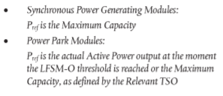
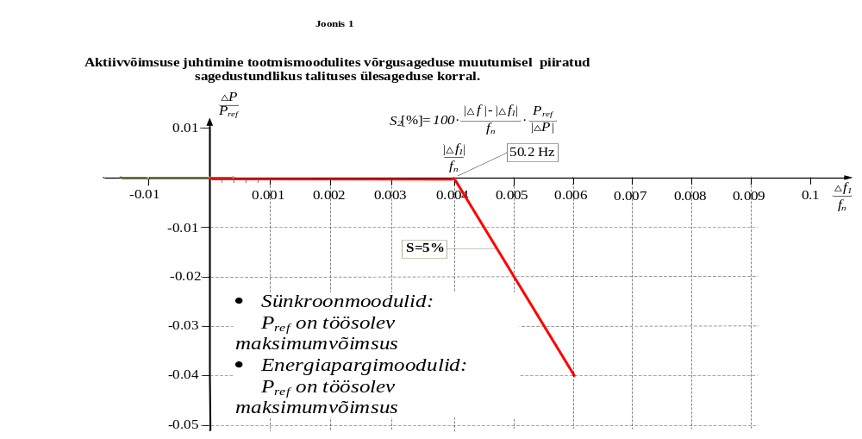

P_{ref} is the reference active power to which ΔΡ is related and may be specified differently for synchronous powergenerating modules and power park modules. ΔΡ is the change in active power output from the power-generating module. fn is the nominal frequency (50 Hz) in the network and Δf is the frequency deviation in the network. At overfrequencies where Δf is above Δf₁ = 0.2, the power-generating module has to provide a negative active power output change according to the droop S₂=5%.

13.2.(f)
General requirements for type A power-generating modules

2. With regard to the limited frequency sensitive mode — overfrequency (LFSM-O), the following shall apply, as determined by the relevant TSO for its control area in coordination with the TSOs of the same synchronous area to ensure minimal impacts on neighbouring areas:
(f) minimum regulating level, the power-generating module be capable continuing operation at this level.
(The smallest power generated is meant under minimal regulation level.)

13.4
General requirements for type A power-generating modules

4. The relevant TSO shall specify admissible active power reduction from maximum output with falling frequency in its control area as a rate of reduction falling within the boundaries, illustrated by the full lines in Figure 2:
a) below 49 Hz falling by a reduction rate of 2 % of the maximum capacity at 50 Hz per 1 Hz frequency drop;
Comment: The selected limit coincides with the level set forth in Article 13(4) of the RfG.

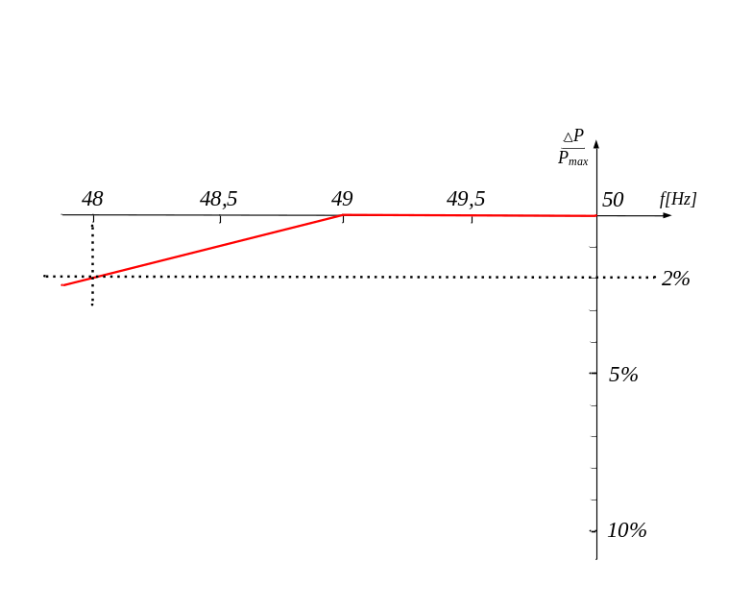
The admissible reduction of the maximum power of the generating module when frequency drops is shown on Figure 2.

13.5
General requirements for type A power-generating modules
The admissible active power reduction from maximum output shall the owner of the production module must describe the technical capacity of the production module in accordance with the environmental conditions in the scope of the technical project.

Article 14.3 (a), 14.3 (b)
General requirements for type B power-generating modules

3. Type B power-generating modules shall fulfil the following requirements in relation to robustness:
(a) with regard to fault-ride-through capability of power-generating modules:
(i) each TSO shall specify a voltage-against-time-profile in line with Figure 3 at the connection point for fault conditions, which describes the conditions in which the power-generating module is capable of staying connected to the network and continuing to operate stably after the power system has been disturbed by secured faults on the transmission system;
(ii) the voltage-against-time-profile shall express a lower limit of the actual course of the phase-to-phase voltages on the network voltage level at the connection point during a symmetrical fault, as a function of time before, during and after the fault;
(iii) the lower limit referred to in point (ii) shall be specified by the relevant TSO using the parameters set out in Figure 3, and within the ranges set out in Tables 3.1 and 3.2;
(iv) each TSO shall specify and make publicly available the pre-fault and post-fault conditions for the fault-ridethrough capability in terms of:
— the calculation of the pre-fault minimum short circuit capacity at the connection point,
— pre-fault active and reactive power operating point of the power-generating module at the connection point
and voltage at the connection point, and
— calculation of the post-fault minimum short circuit capacity at the connection point;
(v) at the request of a power-generating facility owner, the relevant system operator shall provide the pre-fault and
post-fault conditions to be considered for fault-ride-through capability as an outcome of the calculations at the
connection point as specified in point (iv) regarding:
— pre-fault minimum short circuit capacity at each connection point expressed in MVA,
— pre-fault operating point of the power-generating module expressed in active power output and reactive power output at the connection point and voltage at the connection point, and
— post-fault minimum short circuit capacity at each connection point expressed in MVA.
Alternatively, the relevant system operator may provide generic values derived from typical cases;

Figure 3
Põhivõrguettevõtja poolt koostatud fault-ride-through profile of a power-generating module
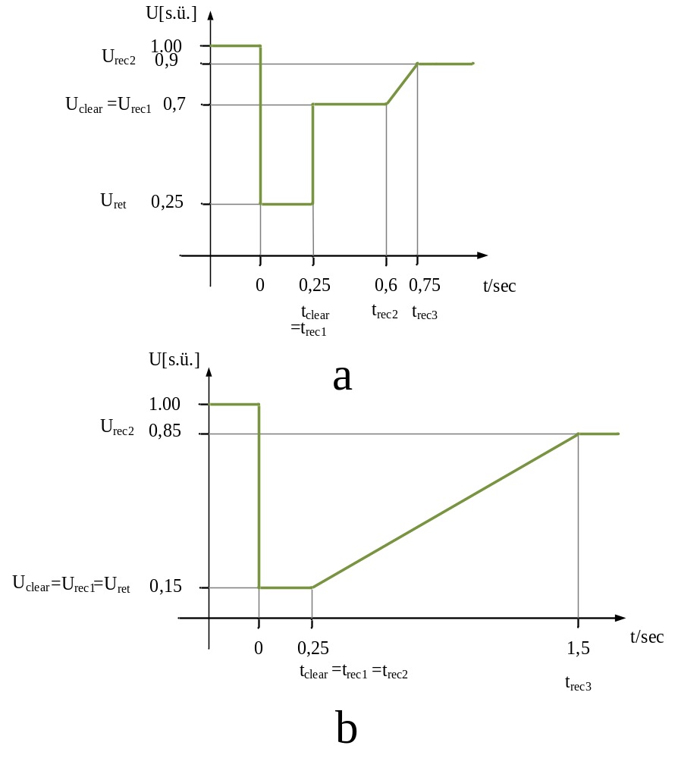
The diagram represents the lower limit of a voltage-against-time profile of the voltage at the connection point, expressed as the ratio of its actual value and its reference 1 pu value before, during and after a fault. Uret is the retained voltage at the connection point during a fault, tclear is the instant when the fault has been cleared. Urec1, Urec2, trec1, trec2 and trec3 specify certain points of lower limits of voltage recovery after fault clearance.

Table 3.1
Parameters for Figure 3 for fault-ride-through capability of synchronous power-generating modules

Voltage values [r.u.] |  | Time [s]
U_{ret}: | 0.25 | t_{clear}: | 0.25
U_{clear}: | 0.7 | t_{rec1}: | t_{clear}:
U_{rec1}: | U_{clear} | t_{rec2}: | 0.60
U_{rec2}: | 0.9 | t_{rec3}: | 0.75

Table 3.2
Parameters for Figure 3 for fault-ride-through capability of power park modules

Voltage values [r.u.] |  | Time [s]
U_{ret}: | 0.15 | t_{clear}: | 0.25
U_{clear}: | 0.15 | t_{rec1}: | t_{clear}:
U_{rec1}: | U_{clear} | t_{rec2}: | t_{rec1}
U_{rec2}: | 0.85 | t_{rec3}: | 1.5

(vi) the power-generating module shall be capable of remaining connected to the network and continuing to operate stably when the actual course of the phase-to-phase voltages on the network voltage level at the connection point during a symmetrical fault, given the pre-fault and post-fault conditions in points (iv) and (v) of paragraph 3(a), remain above the lower limit specified in point (ii) of paragraph 3(a), unless the protection scheme for internal electrical faults requires the disconnection of the power-generating module from the network. The protection schemes and settings for internal electrical faults must not jeopardise fault-ridethrough performance;
(vii) without prejudice to point (vi) of paragraph 3(a), undervoltage protection (either fault-ride-through capability or minimum voltage specified at the connection point voltage) shall be set by the power-generating facility owner according to the widest possible technical capability of the power-generating module, unless the relevant system operator requires narrower settings in accordance with point (b) of paragraph 5. The settings shall be justified by the power-generating facility owner in accordance with this principle;
(b) fault-ride-through capabilities in case of asymmetrical faults shall be specified by each TSO.

The same values apply in the case of asymmetric short circuits.

14.4.a; 14.4.b
General requirements for type B power-generating modules

4. Type B power-generating modules shall fulfil the following requirements relating to system restoration:
(a) the relevant TSO shall specify the conditions under which a power-generating module is capable of reconnecting to the network after an incidental disconnection caused by a network disturbance; and
Frequency range of automatic reconnection: 49.0 – 50.1 Hz
Monitoring time: 60 s
Maximum increase speed of active power: 10% P_{max}/min

(b) installation of automatic reconnection systems shall be subject both to prior authorisation by the relevant system operator and to the reconnection conditions specified by the relevant TSO.

Article 15.2.(a)
General requirements for type C power-generating modules

2. Type C power-generating modules shall fulfil the following requirements relating to frequency stability:
(a) with regard to active power controllability and control range, the power-generating module control system shall be capable of adjusting an active power setpoint in line with instructions given to the power-generating facility owner by the relevant system operator or the relevant TSO.
The relevant system operator or the relevant TSO shall establish the period within which the adjusted active power setpoint must be reached. The relevant TSO shall specify a tolerance (subject to the availability of the prime mover resource) applying to the new setpoint and the time within which it must be reached;

Based on the above, the power regulation capability must comply with the following principle in the ordinary situation:

the deviation between the output active power and the setpoint may be +/-5% of the nominal active power, but not more than +/- 5 MW, whichever is lower.
(1) Outside the ranges specified in subsections (2) to (5), it must be possible to change the output active power of the generating module within the range of constantly generated minimum and maximum capability at least at the speed of 2% Pn/min.
(2) It must be possible to change the active power of a generating module powered by a gas turbine and internal combustion engine at the speed of at least 8% of nominal power per minute. It must be possible to change the power at this speed to the extent of 30% in the range of 40–90% of the device’s nominal power. If this is possible with the devices, the power may be changed at the maximum admissible power regulation speed also if it’s below 40% or over 90% of nominal power.
(3) It must be possible to change the active power of a generating module powered by a steam turbine or a combined cycle at the speed of at least 4% of nominal power per minute. It must be possible to change the power at this speed to the extent of 30% in the range of 60–90% of the device’s nominal power. In certain cases, the percentage of change can be 20. If this is possible with the devices, the power may be changed at the maximum admissible power regulation speed also if it’s below 60% or over 90% of nominal power.
(4) It must be possible to change the active power of a generating module at the speed of at least 8% of nominal power per minute, weather permitting. It must be possible to change the power at this speed to the extent of 30% in the range of 20–100% of the device’s nominal power.
(5) It must be possible to change the active power of a generating module powered by a hydroturbine at the speed of at least 50% of nominal power per minute, water resources permitting. It must be possible to change the power at this speed to the extent of the entire capability.
(6) When a type D generating module corresponds to the conditions specified in Article 6(4)(a) and (b), the conditions of use of active power regulation will be agreed separately between the owner of the generating module and the system operator according to the technical capability of the generating module.

Explanation: this clause applies in combination with clause 15.2b of this document.

15 . 2.c
General requirements for type C power-generating modules

2. Type C power-generating modules shall fulfil the following requirements relating to frequency stability:
In addition to Article 13(2), the following requirements shall apply to type C power-generating modules with regard to limited frequency sensitive mode — underfrequency (LFSM-U):
(i) the power-generating module shall be capable of activating the provision of active power frequency response at a frequency threshold and with a droop specified by the relevant TSO in coordination with the TSOs of the same synchronous area as follows:
— the frequency threshold specified by the TSO shall be 49,8 Hz
— the droop settings specified by the TSO shall be 5 %.

This is represented graphically in Figure 4;

Figure 4
Active power frequency response capability of power-generating modules in LFSM-U

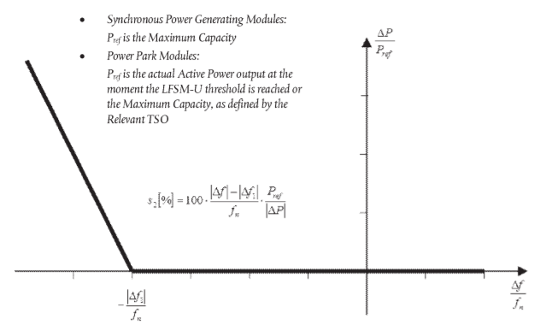

Pref is the reference active power to which ΔΡ is related and may be specified differently for synchronous powergenerating modules and power park modules. ΔΡ is the change in active power output from the powergenerating module. fn is the nominal frequency (50 Hz) in the network and Δf is the frequency deviation in the
network. At underfrequencies where Δf is below Δf₁= 0,2 Hz the power-generating module has to provide a positive active power output change according to the droop S₂ = 5%.

15.2.d.(i); 15.2.d.(iii); 15.2.d.(iv); 15.2.d.(iv); 15.2.d.(v)
General requirements for type C power-generating modules

2. Type C power-generating modules shall fulfil the following requirements relating to frequency stability:
(d) in addition to point (c) of paragraph 2, the following shall apply cumulatively when frequency sensitive mode (‘FSM’) is operating:
(i) the power-generating module shall be capable of providing active power frequency response in accordance with the parameters specified by each relevant TSO within the ranges shown in Table 4. In specifying those parameters, the relevant TSO shall take account of the following facts:
— in case of overfrequency, the active power frequency response is limited by the minimum regulating level,
— in case of underfrequency, the active power frequency response is limited by maximum capacity,
— the actual delivery of active power frequency response depends on the operating and ambient conditions of the power-generating module when this response is triggered, in particular limitations on operation near maximum capacity at low frequencies according to paragraphs 4 and 5 of Article 13 and available primary energy sources;

Table 4
Parameters for active power frequency response in FSM (explanation for Figure 5)

Parameters |  | Ranges
Active power range related to maximum capacity 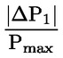 |  | 10 %
Frequency response insensitivity | 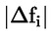 | 10 mHz
Frequency response insensitivity | 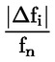 | 0,02%
Frequency response deadband |  | 0–500 mHz
Droop s1 |  | 2–12 %

Figure 5
Active power frequency response capability of power-generating modules in FSM illustrating the case of zero deadband and insensitivity indicates a case where the dead band is in the range of +/-500 mHz

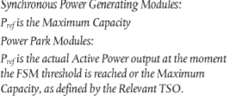
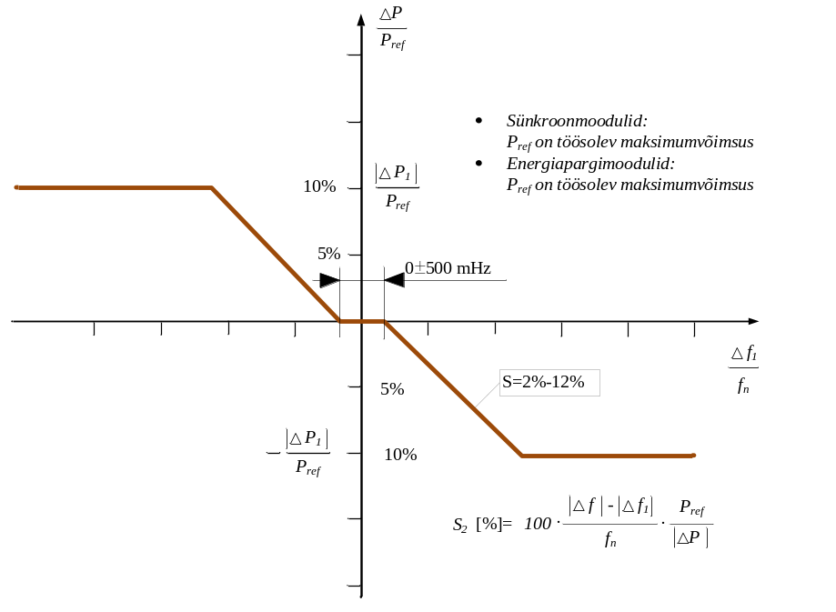

Pref is the reference active power to which ΔΡ is related. ΔΡ is the change in active power output from the power-generating module. fn is the nominal frequency (50 Hz) in the network and Δf is the frequency deviation in the network.
(iii) in the event of a frequency step change, the power-generating module shall be capable of activating full active power frequency response, at or above the full line shown in Figure 6 in accordance with the parameters specified by each TSO (which shall aim at avoiding active power oscillations for the power-generating module) within the ranges given in Table 5. The combination of choice of the parameters specified by the TSO shall take possible technology-dependent limitations into account;
(iv) the initial activation of active power frequency response required shall not be unduly delayed.
If the delay in initial activation of active power frequency response is greater than two seconds, the powergenerating facility owner shall provide technical evidence demonstrating why a longer time is needed.
For power-generating modules without inertia, the relevant TSO may specify a shorter time than two seconds. If the power-generating facility owner cannot meet this requirement they shall provide technical evidence demonstrating why a longer time is needed for the initial activation of active power frequency response;

Figure 6
Active power frequency response capability

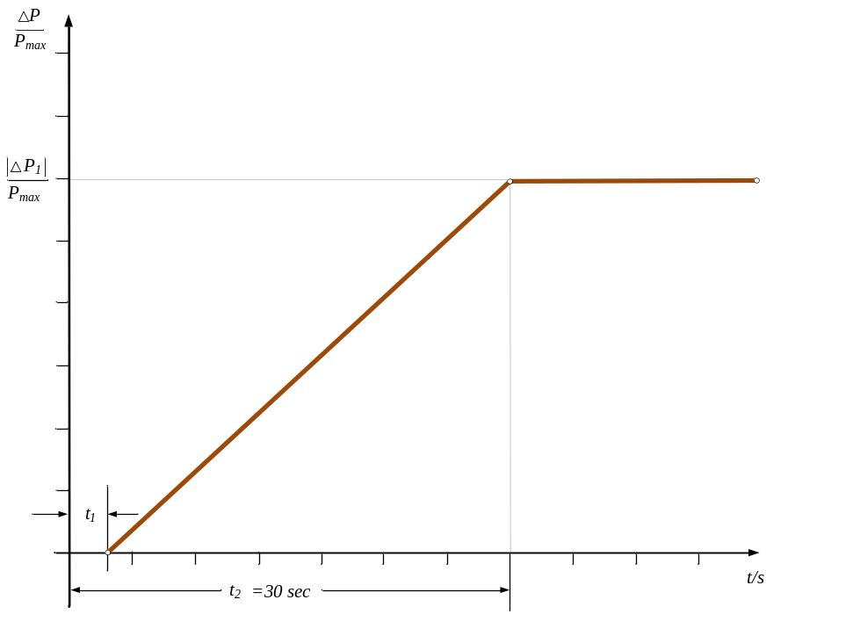

Pmax is the maximum capacity to which ΔΡ relates. ΔΡ is the change in active power output from the powergenerating module. The power-generating module has to provide active power output ΔΡ up to the point ΔΡ₁ in accordance with the times t₁ and t₂ with the values of ΔΡ₁, t₁and t₂ being specified by the relevant TSO according to Table 5. t₁ is the initial delay. t₂ is the time for full activation.
(v) the power-generating module shall be capable of providing full active power frequency response for a period of between 15 and 30 minutes as specified by the relevant TSO. In specifying the period, the TSO shall have regard to active power headroom and primary energy source of the power-generating module;
(vi) within the time limits laid down in point (v) of paragraph 2(d), active power control must not have any adverse impact on the active power frequency response of power-generating modules; L 112/24 EN Official Journal of the European Union 27.4.2016
(vii) the parameters specified by the relevant TSO in accordance with points (i), (ii), (iii) and (v) shall be notified to the relevant regulatory authority. The modalities of that notification shall be specified in accordance with the applicable national regulatory framework;

Active power range related to maximum capacity (frequency response range) | 10 %
For power-generating modules with inertia, the maximum admissible initial delay t₁ unless justified otherwise in line with Article 15(2)(d)(iv) | 2 seconds
For power-generating modules with inertia, the maximum admissible initial delay t₁ unless justified otherwise in line with Article 15(2)(d)(iv) | 0,5 seconds
Maximum admissible choice of full activation time t₂, unless longer activation times are allowed by the relevant TSO for reasons of system stability | 30 seconds

15.2.g
g) with regard to real-time monitoring of FSM:
(i) to monitor the operation of active power frequency response, the communication interface shall be equipped to transfer in real time and in a secured manner from the power-generating facility to the network control centre of the relevant system operator or the relevant TSO, at the request of the relevant system operator or the relevant TSO, at least the following signals:
— status signal of FSM (on/off),
— scheduled active power output,
— actual value of the active power output,
— actual parameter settings for active power frequency response,
— droop and deadband;
(ii) the relevant system operator and the relevant TSO shall specify additional signals to be provided by the powergenerating facility by monitoring and recording devices in order to verify the performance of the active power frequency response provision of participating power-generating modules.

15.6.e
6. Type C power-generating modules shall fulfil the following general system management requirements:
(e) the relevant system operator shall specify, in coordination with the relevant TSO, minimum and maximum limits on rates of change of active power output (ramping limits) in both an up and down direction of change of active power output for a power-generating module, taking into consideration the specific characteristics of prime mover technology.
The upper limits are determined on project basis, considering the technical capability of the generating module. Minimal regulation speeds are given in Article 15.2.(a).

16.3.a.(i); 16.3.c
General requirements for type D power-generating modules
3. Type D power-generating modules shall fulfil the following requirements in relation to robustness: (a) with regard to fault-ride-through capability:
(i) power-generating modules shall be capable of staying connected to the network and continuing to operate stably after the power system has been disturbed by secured faults. That capability shall be in accordance with a voltage-against-time profile at the connection point for fault conditions specified by the relevant TSO.
The voltage-against-time-profile shall express a lower limit of the actual course of the phase-to-phase voltages on the network voltage level at the connection point during a symmetrical fault, as a function of time before, during and after the fault. L 112/30 EN Official Journal of the European Union 27.4.2016
That lower limit shall be specified by the relevant TSO, using the parameters set out in Figure 3 and within the ranges set out in Tables 7.1 and 7.2 for type D power-generating modules connected at or above the 110 kV level.
That lower limit shall also be specified by the relevant TSO, using parameters set out in Figure 3 and within the ranges set out in Tables 3.1 and 3.2 for type D power-generating modules connected below the 110 kV level;
(ii) each TSO shall specify the pre-fault and post-fault conditions for the fault-ride-through capability referred to in point (iv) of Article 14(3)(a). The specified pre-fault and post-fault conditions for the fault-ride-through capability shall be made publicly available.
Table 7.1
Parameters for Figure 3 for fault-ride-through capability of synchronous power-generating modules
Voltage parameters (pu) |  | Time parameters (seconds)
U_{ret}: | 0 | t_{clear}: | 0,25
U_{clear}: | 0,25 | t_{rec1}: | t_{clear}
U_{rec1}: | 0,5–0,7 | t_{rec2}: | t_{rec1} – 0,7
U_{rec2}: | 0,9 | t_{rec3}: | 0,75
Table 7.2
Parameters for Figure 3 for fault-ride-through capability of power park modules
Voltage parameters (pu) |  | Time parameters (seconds)
U_{ret}: | 0 | t_{clear}: | 0,25
U_{clear}: | U_{ret} | t_{rec1}: | t_{clear}
U_{rec1}: | U_{clear} | t_{rec2}: | t_{rec1}
U_{rec2}: | 0,85 | t_{rec3}: | 1,5

(c) fault-ride-through capabilities in case of asymmetrical faults shall be specified by each TSO.

The same values apply in the case of asymmetric short circuits.
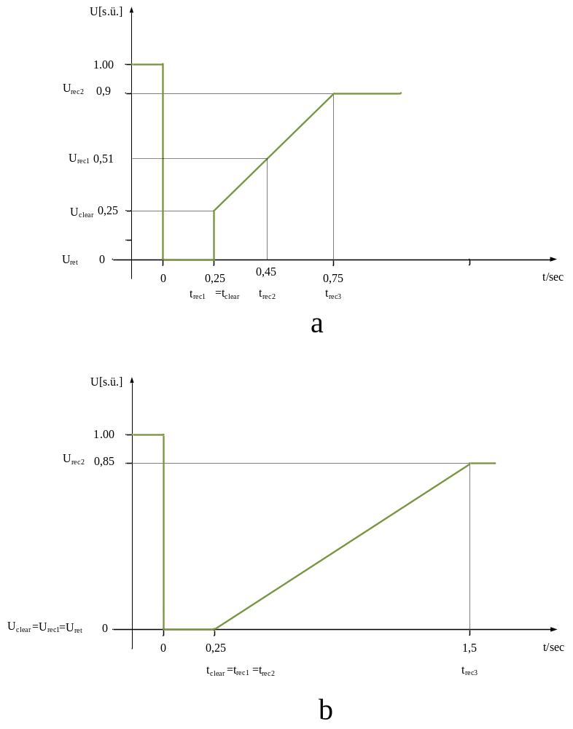
The lower limit of the voltage at the connection point is indicated on the voltage time curve in Figure 7; the actual voltage is indicated as a ratio in respect of reference value 1 (in relative units) before the fault, during the fault and after the fault. U_{ret} is the residual voltage during the fault at the connection point, t_{clear} is the moment of fault separation. U_{rec1}, U_{rec2}, t_{rec1}, t_{rec2} and t_{rec3} mark certain points where the lower limit of voltage recovery changes after the separation of the fault.

15.3
3. With regard to voltage stability, type C power-generating modules shall be capable of automatic disconnection when voltage at the connection point reaches levels specified by the relevant system operator in coordination with the relevant TSO.
The terms and settings for actual automatic disconnection of power-generating modules shall be specified by the relevant system operator in coordination with the relevant TSO.

Type C generating modules may be automatically disconnected if the voltages exit the limits specified in Table 6.1 of Article 16.2.a and considering the required fault-ride-through capability.

Type D generating modules may be automatically disconnected if the voltages exit the limits specified in Tables 6.1 and 6.2 of Article 16.2.a and considering the required fault-ride-through capability.

16.2.a.(i); 16.2.a.(ii); 16.2.a.(iii); 16.2.a.(v)
General requirements for type D power-generating modules
2. Type D power-generating modules shall fulfil the following requirements relating to voltage stability: (a) with regard to voltage ranges:
(i) without prejudice to point (a) of Article 14(3) and point (a) of paragraph 3 below, a power-generating module shall be capable of staying connected to the network and operating within the ranges of the network voltage at the connection point, expressed by the voltage at the connection point related to the reference 1 pu voltage, and for the time periods specified in Tables 6.1 and 6.2;
(ii) the relevant TSO may specify shorter periods of time during which power-generating modules shall be capable of remaining connected to the network in the event of simultaneous overvoltage and underfrequency or simultaneous undervoltage and overfrequency;
Explanation: Elering does not apply this as a general rule, but provides the option to use the given requirement on project basis if necessary. (This point can only be applied to mitigate the requirements.)

(iv) for the 400 kV grid voltage level (or alternatively commonly referred to as 380 kV level), the reference 1 pu value is 400 kV; for other grid voltage levels, the reference 1 pu voltage may differ for each system operator in the same synchronous area;
(v) notwithstanding the provisions of point (i), the relevant TSOs in the Baltic synchronous area may require power-generating modules to remain connected to the 400 kV network in the voltage range limits and for the time periods that apply in the Continental Europe synchronous area;

Table 6.1
Synchronous area | Voltage range | Time period for operation
Continental Europe | 0,85–0,90 s.ü. | 60 minutes
Continental Europe | 0,90–1,118 s.ü. | Unlimited
Continental Europe | 1,118–1,15 s.ü. | To be specified by each TSO, but not less than 20 minutes and not more than 60 minutes
Nordic | 0,90–1,05 s.ü. | Unlimited
Nordic | 1,05–1,10 s.ü. | 60 minutes
Great Britain | 0,90–1,10 s.ü. | Unlimited
Ireland and Northern Ireland | 0,90–1,118 s.ü. | Unlimited
Baltic | 0,85–0,90 s.ü. | 30 minutes
Baltic | 0,90–1,118 s.ü. | Unlimited
Baltic | 1,118–1,15 s.ü. | 20 minutes

The table shows the minimum time periods during which a power-generating module must be capable of operating for voltages deviating from the reference 1 pu value at the connection point without disconnecting from the network, where the voltage base for pu values is from 110 kV to 300 kV.
Table 6.2
Synchronous area | Voltage range | Period
Continental Europe | 0.85–0.90 r.u. | 60 minutes
Continental Europe | 0.90–1.05 r.u. | Unlimited
Continental Europe | 1.05–1.10 r.u. | To be specified by each TSO, but not less than 20 minutes and not more than 60 minutes
Nordic | 0.90–1.05 r.u. | Unlimited
Nordic | 1.05–1.10 r.u. | To be specified by each TSO, but not more than 60 minutes
Great Britain | 0.90–1.05 r.u. | Unlimited
Great Britain | 1.05–1.10 r.u. | 15 minutes
Ireland and Northern Ireland | 0.90–1.05 r.u. | Unlimited
Baltic | 0.88–0.90 r.u. | 20 minutes
Baltic | 0.90–1.097 r.u. | Unlimited
Baltic | 1.097–1.15 r.u. | 20 minutes

The table shows the minimum time periods during which a power-generating module must be capable of operating for voltages deviating from the reference 1 pu value at the connection point without disconnecting from the network where the voltage base for pu values is from 300 kV to 400 kV.

Article 17
Requirements for type B synchronous power-generating modules
2. Type B synchronous power-generating modules shall fulfil the following additional requirements relating to voltage stability:
(a) with regard to reactive power capability, the relevant system operator shall have the right to specify the capability of a synchronous power-generating module to provide reactive power;

Type B synchronous modules must have the capability to regulate reactive power within the scope of technically possible regulation capability at the request of the respective system operator.

18.2.a
Requirements for type C synchronous power-generating modules

Type C synchronous power-generating modules shall fulfil the following additional requirements in relation to voltage stability:
(a) with regard to reactive power capability, the relevant system operator may specify supplementary reactive power to be provided if the connection point of a synchronous power-generating module is neither located at the high-voltage terminals of the step-up transformer to the voltage level of the connection point nor at the alternator terminals, if no step-up transformer exists. This supplementary reactive power shall compensate the reactive power demand of the high-voltage line or cable between the high-voltage terminals of the step-up transformer of the synchronous power-generating module or its alternator terminals, if no step-up transformer exists, and the connection point and shall be provided by the responsible owner of that line or cable;
The capability to regulate reactive power must be guaranteed in respect of the connection point according to the requirements of Article 18.2.b, but no more than the requirements specified in Article 18.2.b.

Explanation: Only the synchronous module, not the connection point, is observed in the case of a mixed installation.

18.2.b.(i)
Requirements for type C synchronous power-generating modules
2. Type C synchronous modules must comply with the following additional requirements in respect of voltage stability:
(b) with regard to reactive power capability at maximum capacity:
(i) the relevant system operator in coordination with the relevant TSO shall specify the reactive power provision capability requirements in the context of varying voltage. For that purpose the relevant system operator shall specify a U-Q/Pmax-profile within the boundaries of which the synchronous power-generating module shall be capable of providing reactive power at its maximum capacity. The specified U-Q/Pmax profile may take any shape, having regard to the potential costs of delivering the capability to provide reactive power production at high voltages and reactive power consumption at low voltages;

Figure 7
U-Q/Pmax-profile of a synchronous power-generating module
The diagram represents boundaries of a U-Q/Pmax-profile by the voltage at the connection point, expressed by the ratio of its actual value and the reference 1 pu value, against the ratio of the reactive power (Q) and the maximum capacity (Pmax). The position, size and shape of the inner envelope are indicative.
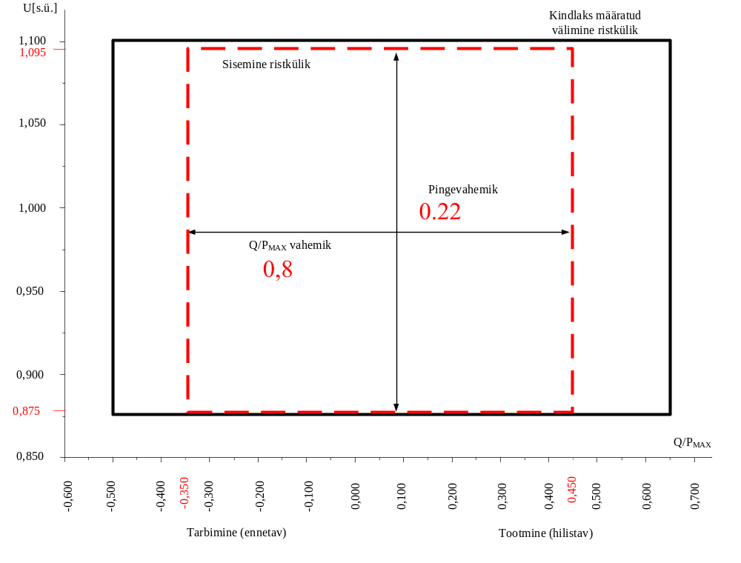
Determined outer rectangle
Inner rectangle
Voltage range
Q/P_{MAX} range
Consumption (pre-emptive)
Production (delaying)

The diagram represents boundaries of a U-Q/Pmax-profile by the voltage at the connection point, expressed by the ratio of its actual value and the reference 1 pu value, against the ratio of the reactive power (Q) and the maximum capacity (Pmax). The position, size and shape of the inner envelope are indicative.
Table 8
Parameters for the inner envelope in Figure 8
Synchronous area | Maximum range of Q/Pmax | Maximum range of steadystate voltage level in PU
Continental Europe | 0,95 | 0,225
Nordic | 0,95 | 0,150
Great Britain | 0,95 | 0,225
Ireland and Northern Ireland | 1,08 | 0,218
Baltic | 1,0 | 0,220

19.2.b.(v)
Requirements for type D synchronous power-generating modules
2. Type D synchronous power-generating modules shall fulfil the following additional requirements in relation to voltage stability:
(a) the parameters and settings of the components of the voltage control system shall be agreed between the powergenerating facility owner and the relevant system operator, in coordination with the relevant TSO;
(b) the agreement referred to in subparagraph (a) shall cover the specifications and performance of an automatic voltage regulator (‘AVR’) with regard to steady-state voltage and transient voltage control and the specifications and performance of the excitation control system. The latter shall include:
(v) a PSS function to attenuate power oscillations, if the synchronous power-generating module size is above a value of maximum capacity specified by the relevant TSO.
Explanation: All of the synchronous modules connected to the transmission system irrespective of power.

20.2.a
Requirements for type B power park modules
2. Type B power park modules shall fulfil the following additional requirements in relation to voltage stability:
(a) with regard to reactive power capability, the relevant system operator shall have the right to specify the capability of a power park module to provide reactive power;
Type B power park modules must have the capability to regulate reactive power within the scope of technically possible regulation capability at the request of the respective system operator.

20.2.b; 20.2.c
Requirements for type B power park modules
(b) the relevant system operator in coordination with the relevant TSO shall have the right to specify that a power park module be capable of providing fast fault current at the connection point in case of symmetrical (3-phase) faults, under the following conditions:
(i) the power park module shall be capable of activating the supply of fast fault current either by:
— ensuring the supply of the fast fault current at the connection point, or
— measuring voltage deviations at the terminals of the individual units of the power park module and providing a fast fault current at the terminals of these units;
(ii) the relevant system operator in coordination with the relevant TSO shall specify:
— how and when a voltage deviation is to be determined as well as the end of the voltage deviation,
— the characteristics of the fast fault current, including the time domain for measuring the voltage deviation and fast fault current, for which current and voltage may be measured differently from the method specified in Article 2,
— the timing and accuracy of the fast fault current, which may include several stages during a fault and after its clearance;
c) with regard to the supply of fast fault current in case of asymmetrical (1-phase or 2-phase) faults, the relevant system operator in coordination with the relevant TSO shall have the right to specify a requirement for asymmetrical current injection.
Not to be applied as a requirement in this Network Code. It’s highly probable that it will become necessary in the future and the exact circumstances will become clear after the completion of the synchronisation studies in the second half of 2018. If the power park module has the capability, the effect will be agreed between the producer and the system operator.

21.3.a; 21.3.b; 21.3.c.(i); 21.3.c.(ii)
Requirements for type C power park modules
3 Type C power park modules shall fulfil the following additional requirements in relation to voltage stability:
(a) with regard to reactive power capability, the relevant system operator may specify supplementary reactive power to be provided if the connection point of a power park module is neither located at the high-voltage terminals of the step-up transformer to the voltage level of the connection point nor at the convertor terminals, if no step-up transformer exists. This supplementary reactive power shall compensate the reactive power demand of the highvoltage line or cable between the high-voltage terminals of the step-up transformer of the power park module or its convertor terminals, if no step-up transformer exists, and the connection point and shall be provided by the responsible owner of that line or cable.
The reactive power capability of the generating module in respect of the connection point must be guaranteed at least according to the requirements in points b) and c) of this article.
Explanation: Only the generating module is observed in the case of a mixed installation.
(b) with regard to reactive power capability at maximum capacity:
(i) the relevant system operator in coordination with the relevant TSO shall specify the reactive power provision capability requirements in the context of varying voltage. To that end, it shall specify a U-Q/Pmax-profile that may take any shape within the boundaries of which the power park module shall be capable of providing reactive power at its maximum capacity;
(ii) the U-Q/Pmax-profile shall be specified by each relevant system operator in coordination with the relevant TSO in conformity with the following principles:
— the U-Q/Pmax-profile shall not exceed the U-Q/Pmax-profile envelope, represented by the inner envelope in Figure 8,
— the dimensions of the U-Q/Pmax-profile envelope (Q/Pmax range and voltage range) shall be within the values specified for each synchronous area in Table 9,
— the position of the U-Q/Pmax-profile envelope shall be within the limits of the fixed outer envelope set out in Figure 8, and
— the specified U-Q/Pmax profile may take any shape, having regard to the potential costs of delivering the capability to provide reactive power production at high voltages and reactive power consumption at low voltages;

Figure 8
U-Q/Pmax-profile of a power park module
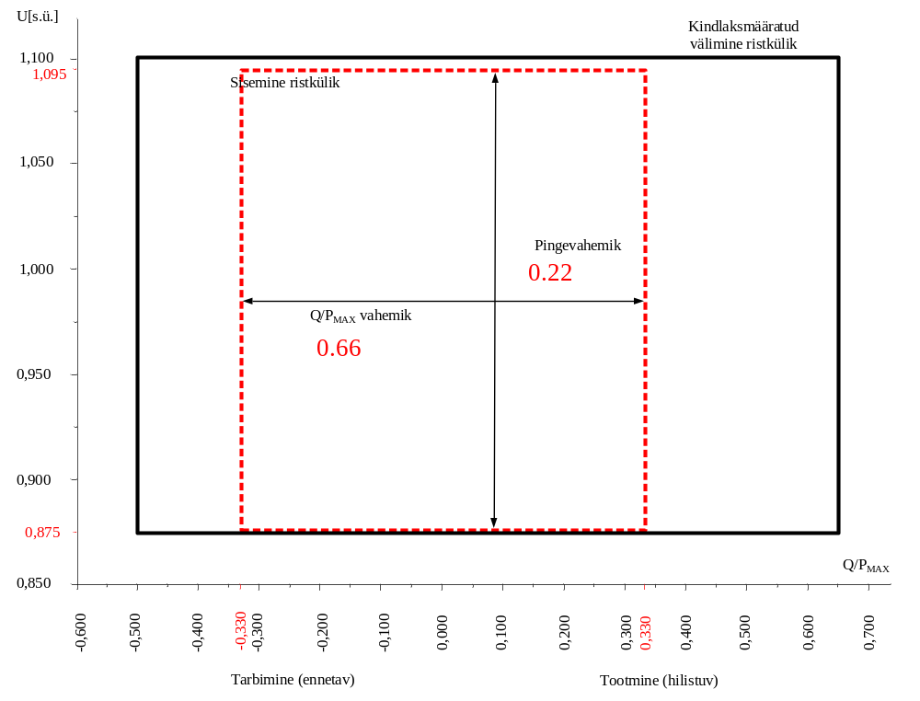
Determined outer rectangle
Inner rectangle
Voltage range
Q/P_{MAX} range
Consumption (pre-emptive)
Production (delaying)

The diagram represents boundaries of a U-Q/Pmax-profile by the voltage at the connection point, expressed by the ratio of its actual value and its reference 1 pu value, against the ratio of the reactive power (Q) and the maximum capacity (Pmax). The position, size and shape of the inner envelope are indicative.

Table 9
Parameters for the inner envelope in Figure 8
Synchronous area | Maximum range of Q/Pmax | Maximum range of steadystate voltage level in PU
Continental-Euroope | 0,75 | 0,225
Nordic | 0,95 | 0,150
Great Britain | 0,66 | 0,225
Ireland and Northern Ireland | 0,66 | 0,218
Baltic | 0,80 | 0,220

(iii) the reactive power provision capability requirement applies at the connection point. For profile shapes other than rectangular, the voltage range represents the highest and lowest values. The full reactive power range is therefore not expected to be available across the range of steady-state voltages;

(c) with regard to reactive power capability below maximum capacity:
(i) the relevant system operator in coordination with the relevant TSO shall specify the reactive power provision capability requirements and shall specify a P-Q/Pmax-profile that may take any shape within the boundaries of which the power park module shall be capable of providing reactive power below maximum capacity;
(ii) the P-Q/Pmax-profile shall be specified by each relevant system operator in coordination with the relevant TSO, in conformity with the following principles:
— the P-Q/Pmax-profile shall not exceed the P-Q/Pmax-profile envelope, represented by the inner envelope in Figure 9,
— the Q/Pmax range of the P-Q/Pmax-profile envelope is specified for each synchronous area in Table 9,
— the active power range of the P-Q/Pmax-profile envelope at zero reactive power shall be 1 pu,
— the P-Q/Pmax-profile can be of any shape and shall include conditions for reactive power capability at zero active power, and
— the position of the P-Q/Pmax-profile envelope shall be within the limits of the fixed outer envelope set out in Figure 9;
(iii) ) when operating at an active power power output below maximum capacity (P<P_{max})
the power park module shall be capable of providing reactive power at any operating point inside its P-Q/Pmax-profile, if all units of that power park module which generate power are technically available that is to say they are not out of service due to maintenance or failure, otherwise there may be less reactive power capability, taking into consideration the technical availabilities;

Figure 9
P-Q/Pmax-profile of a power park module
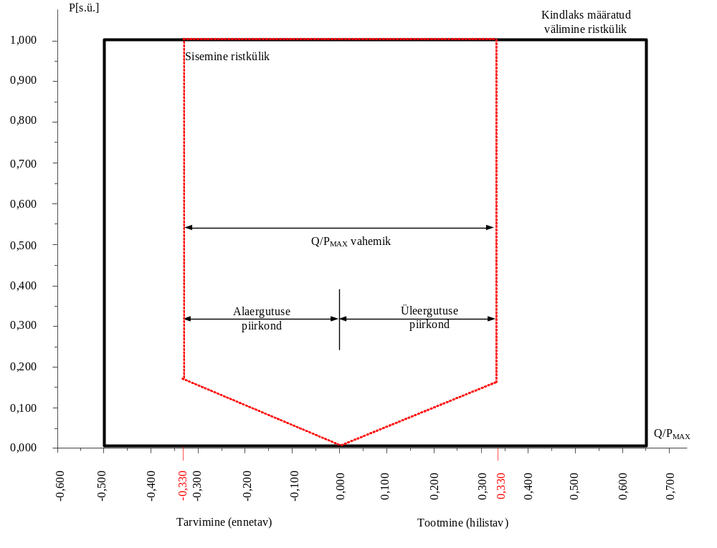
Determined outer rectangle
Inner rectangle
Q/P_{MAX} range
Under-excitation area
Over-excitation area
Consumption (pre-emptive)
Production (delaying)

The diagram represents boundaries of a P-Q/Pmax-profile at the connection point by the active power, expressed by the ratio of its actual value and the maximum capacity pu, against the ratio of the reactive power (Q) and the maximum capacity (Pmax). The position, size and shape of the inner envelope are indicative.
(iv) the power park module shall be capable of moving to any operating point within its P-Q/Pmax profile in appropriate timescales to target values requested by the relevant system operator;

25.1
Voltage stability requirements applicable to AC-connected offshore power park modules
1. Without prejudice to point (a) of Article 14(3) and point (a) of Article 16(3), an AC-connected offshore power park module shall be capable of staying connected to the network and operating within the ranges of the network voltage at the connection point, expressed by the voltage at the connection point related to reference 1 pu voltage, and for the time periods specified in Table 10.

Synchronous area | Voltage range | Time period for operation
Baltic power system | 0.85–0.90 r.u. (*) | 30 minutes
Baltic power system | 0.90–1.118 r.u. (*) | Unlimited
Baltic power system | 1.118–1.15 r.u. (*) | 20 minutes
Baltic power system | 0.88–0.90 r.u. (**) | 20 minutes
Baltic power system | 0.90–1.097 r.u. (**) | Unlimited
Baltic power system | 1.097–1.15 r.u. (**) | 20 minutes
(*) The voltage base for pu values is below 300 kV.
(**) The voltage base for pu values is from 300 kV to 400 kV.
The table shows the minimum period during which an AC-connected offshore power park module must be capable of operating over different voltage ranges deviating from the reference 1 pu value without disconnecting.

16.2.a.(iii); 16.2.a.(v)
General requirements for type D power-generating modules
2. Type D power-generating modules shall fulfil the following requirements relating to voltage stability: (a) with regard to voltage ranges:
(i) without prejudice to point (a) of Article 14(3) and point (a) of paragraph 3 below, a power-generating module shall be capable of staying connected to the network and operating within the ranges of the network voltage at the connection point, expressed by the voltage at the connection point related to the reference 1 pu voltage, and for the time periods specified in Tables 6.1 and 6.2;
(ii) the relevant TSO may specify shorter periods of time during which power-generating modules shall be capable of remaining connected to the network in the event of simultaneous overvoltage and underfrequency or simultaneous undervoltage and overfrequency;
(iii) notwithstanding the provisions of point (i), the relevant TSO in Spain may require power-generating modules to be capable of remaining connected to the network in the voltage range between 1,05 pu and 1,0875 pu for an unlimited period;
(iv) for the 400 kV grid voltage level (or alternatively commonly referred to as 380 kV level), the reference 1 pu value is 400 kV; for other grid voltage levels, the reference 1 pu voltage may differ for each system operator in the same synchronous area;
(v) notwithstanding the provisions of point (i), the relevant TSOs in the Baltic synchronous area may require power-generating modules to remain connected to the 400 kV network in the voltage range limits and for the time periods that apply in the Continental Europe synchronous area;

Table 6.1
Synchronous area | Voltage range | Time period for operation
Baltic | 0,85–0,90 s.ü. | 30 minutes
Baltic | 0,90–1,118 s.ü. | Unlimited
Baltic | 1,118–1,15 s.ü. | 20 minutes

The table shows the minimum time periods during which a power-generating module must be capable of operating for voltages deviating from the reference 1 pu value at the connection point without disconnecting from the network, where the voltage base for pu values is from 110 kV to 300 kV.

Table 6.2
Synchronous area | Voltage range | Time period for operation
Balti energiasüsteem | 0,88–0,90 s.ü. | 20 minutes
Balti energiasüsteem | 0,90–1,097 s.ü. | Unlimited
Balti energiasüsteem | 1,097–1,15 s.ü. | 20 minutes
The table shows the minimum time periods during which a power-generating module must be capable of operating for voltages deviating from the reference 1 pu value at the connection point without disconnecting from the network where the voltage base for pu values is from 300 kV to 400 kV.

25.5
Voltage stability requirements applicable to AC-connected offshore power park modules
5. The reactive power capability at maximum capacity specified in point (b) of Article 21(3) shall apply to ACconnected offshore power park modules, except for Table 9. Instead, the requirements of Table 11 shall apply

Synchronous area | Maximum range of Q/Pmax | Maximum range of steady-state voltage level in PU
Continental Europe | 0.75 | 0.225
Nordic | 0.95 | 0.150
Great Britain | 0 (***)  0.33 (****) | 0.225
Ireland and Northern Ireland | 0.66 | 0.218
Baltic | 0.8 | 0.22
Explanation: same as the type D requirements in article 21.

15.5.c.(iii)
General requirements for type C power-generating modules
5. Type C power-generating modules shall fulfil the following requirements relating to system restoration:
(c) with regard to quick re-synchronisation capability:
(iii) power-generating modules shall be capable of continuing operation following tripping to houseload, irrespective of any auxiliary connection to the external network for 6 hours.

Explanation: The houseload requirement only applies to the generating modules the launch time of which after disconnection from the network is longer than 15 min. The six-hour requirement arises from the maximum time of the control centres during which the generating equipment can be reconnected to the network if the system goes out.

17.3
Requirements for type B synchronous power-generating modules
3. With regard to robustness, type B synchronous power-generating modules shall be capable of providing post-fault active power recovery in the case of which the active power must recover without delay as fast as technically possible, but not longer than 1s after the recovery of the network voltage, and the output power after elimination of the fault may not decrease by more than 10% of nominal active power in comparison with the level before the fault.

20.3.a
Requirements for type B power park modules

3. Type B power park modules shall fulfil the following additional requirements in relation to robustness:
(a) the relevant TSO shall specify the post-fault active power recovery that the power park module is capable of providing and shall specify:
i) | Reactive power must be recovered after a fault no later than at the moment when the network tension achieves the level of 0.85 p.u.

ii) | Active power must be recovered without delay as fast as technically possible, but no later than 1s after the recovery of the network voltage.

iii) | The output power in comparison with the level before the fault may not decrease by more than 10% of the nominal active power.

14.5.d
General requirements for type B generating modules
5. Type B power-generating modules shall fulfil the following general system management requirements:
(d) with regard to information exchange:
i) Generating modules must be able to exchange information with the respective system operator or the respective TSO in real time or regularly with a timestamp, as determined by the respective system operator or the respective TSO.
ii) The respective system operator, with the approval of the respective TSO, must determine the content and exact list of the data transmitted by the generation facility.

In relation to information exchange, the generating modules must be able to exchange information with the respective system operator or the respective TSO in real time or regularly with a timestamp, as determined by the respective system operator or the respective TSO in the respective Connection Conditions.

15.6.a
General requirements for type C generating modules
6. Type C power-generating modules shall fulfil the following general system management requirements:
(a) with regard to loss of angular stability or loss of control, a power-generating module shall be capable of disconnecting automatically from the network in order to help preserve system security or to prevent damage to the power-generating module. The power-generating facility owner and the relevant system operator in coordination with the relevant TSO shall agree on the criteria for detecting loss of angular stability or loss of control;

On project-basis.(Does not change the RfG wording.)
Explanation: According to relay protection calculations. Asynchronous operation protection is generally used. The system operator may also add a reserving asynchronous operation protection at the connection point.

15.6.b.(i); 15.6.b.(ii); 15.6.b.(iii); 15.6.b.(iv)
General requirements for type C power-generating modules
6. Type C power-generating modules shall fulfil the following general system management requirements:
(b)with regard to instrumentation:
(i) power-generating facilities shall be equipped with a facility to provide fault recording and monitoring of dynamic system behaviour. This facility shall record the following parameters: — voltage,
— active power,
— reactive power, and
— frequency.
The relevant system operator shall have the right to specify quality of supply parameters to be complied with on condition that reasonable prior notice is given;
(ii) the settings of the fault recording equipment, including triggering criteria and the sampling rates shall be agreed between the power-generating facility owner and the relevant system operator in coordination with the relevant TSO;
(iii) the dynamic system behaviour monitoring shall include an oscillation trigger specified by the relevant system operator in coordination with the relevant TSO, with the purpose of detecting poorly damped power oscillations;
(iv) the facilities for quality of supply and dynamic system behaviour monitoring shall include arrangements for the power-generating facility owner, and the relevant system operator and the relevant TSO to access the information. The communications protocols for recorded data shall be agreed between the power-generating facility owner, the relevant system operator and the relevant TSO;

Explanation: This will be determined in the connection conditions of the respective system operator.

15.6.c.(iii)
General requirements for type C power-generating modules
6. Type C power-generating modules shall fulfil the following general system management requirements:
(c) with regard to the simulation models:
(i) at the request of the relevant system operator or the relevant TSO, the power-generating facility owner shall provide simulation models which properly reflect the behaviour of the power-generating module in both steadystate and dynamic simulations (50 Hz component) or in electromagnetic transient simulations. The power-generating facility owner shall ensure that the models provided have been verified against the results of compliance tests referred to in Chapters 2, 3 and 4 of Title IV, and shall notify the results of the verification to the relevant system operator or relevant TSO. Member States may require that such verification be carried out by an authorised certifier;
(ii) the models provided by the power-generating facility owner shall contain the following sub-models, depending on the existence of the individual components:
— alternator and prime mover,
— speed and power control,
— voltage control, including, if applicable, power system stabiliser (‘PSS’) function and excitation control system,
— power-generating module protection models, as agreed between the relevant system operator and the powergenerating facility owner, and
— converter models for power park modules;
(iii) the request by the relevant system operator referred to in point (i) shall be coordinated with the relevant TSO. It shall include:
— the format in which models are to be provided,
— the provision of documentation on a model's structure and block diagrams,
— an estimate of the minimum and maximum short circuit capacity at the connection point, expressed in MVA, as an equivalent of the network;
(iv) the power-generating facility owner shall provide recordings of the power-generating module's performance to the relevant system operator or relevant TSO if requested. The relevant system operator or relevant TSO may make such a request, in order to compare the response of the models with those recordings;

Explanation: Detailed explanations and guidelines about the models of generating modules will be specified in the connection conditions of the respective system operator.

16.4
General requirements for type D power-generating modules
4. Type D power-generating modules shall fulfil the following general system management requirements:
(a) with regard to synchronisation, when starting a power-generating module, synchronisation shall be performed by the power-generating facility owner only after authorisation by the relevant system operator;
(b) the power-generating module shall be equipped with the necessary synchronisation facilities; 27.4.2016 EN Official Journal of the European Union L 112/31
(c) synchronisation of power-generating modules shall be possible at frequencies within the ranges set out in Table 2;
(d) the relevant system operator and the power-generating facility owner shall agree on the settings of synchronisation devices to be concluded prior to operation of the power-generating module. This agreement shall cover:
(i) voltage; ,85…1,15 Un
(ii) frequency; 47,5 …51,5 Hz
(iii) phase angle range; 60 degrees
(iv) phase sequence; phase sequence inspection
(v) deviation of voltage and frequency. 15% Un and 100 mHz

21.2
Requirements for type C power park modules
2. Type C power park modules shall fulfil the following additional requirements in relation to frequency stability:
(a) the relevant TSO shall have the right to specify that power park modules be capable of providing synthetic inertia during very fast frequency deviations;
(b) the operating principle of control systems installed to provide synthetic inertia and the associated performance parameters shall be specified by the relevant TSO.
Not applied as a requirement in this Network Code. It’s highly probable that it will become necessary in the future and the exact circumstances will become clear after the completion of the synchronisation studies in the second half of 2018. If the power park module has the capability, the effect will be agreed between the producer and the system operator.

21.3.d.iv
Requirements for type C power park modules
3. Type C power park modules shall fulfil the following additional requirements in relation to voltage stability:
(d) with regard to reactive power control modes:
(iv) Following a step change in voltage, the power park module shall be capable of achieving 90 % of the change in reactive power output within a time t1 to be specified by the relevant system operator in the range of 1 to 5 seconds, and must settle at the value specified by the slope within a time t2 to be specified by the relevant system operator in the range of 5 to 60 seconds, with a steady-state reactive tolerance no greater than 5 % of the maximum reactive power. The relevant system operator shall specify the time specifications;
They are: t1=5s; t2=60 s

21.3.f
Requirements for type C power park modules
Type C power park modules shall fulfil the following additional requirements in relation to voltage stability:
(f) with regard to power oscillations damping control, if specified by the relevant TSO a power park module shall be capable of contributing to damping power oscillations. The voltage and reactive power control characteristics of power park modules must not adversely affect the damping of power oscillations.
Explanation: Type D power park modules must be able to participate in dampening the oscillation of power.

21.3.e
Requirements for type C power park modules
Type C power park modules shall fulfil the following additional requirements in relation to voltage stability:
(e) with regard to prioritising active or reactive power contribution, the relevant TSO shall specify whether active power contribution or reactive power contribution has priority during faults for which fault-ride-through capability is required. If priority is given to active power contribution, this provision has to be established no later than 150 ms from the fault inception;

Explanation: Contribution of reactive power in the case of faults is preferred.

