EXPLANATORY DOCUMENT
on the Proposal of Finnish, Estonian and Latvian TSOs of Baltic CCR TSOs’ Common Methodology for Splitting Long-Term Cross-Zonal Capacity in Accordance with Article 16 of Commission Regulation (EU) 2016/1719 of 26 September 2016 Establishing a Guideline on Forward Capacity Allocation
19.01.2026

1. Introduction
This document serves as the supporting document for the Proposal of Finnish, Estonian and Latvian TSOs of Baltic CCR TSOs’ Common Methodology for Splitting Long-Term Cross-Zonal Capacity in Accordance with Article 16 of Commission Regulation (EU) 2016/1719 of 26 September 2016 Establishing a Guideline on Forward Capacity Allocation (hereafter referred to as the "LTCS"). It outlines the LTCS for the long-term time frame for the Baltic Capacity Calculation Region (CCR) and aims to provide an explanation, background, and motivation for the proposed legal text of the methodology.
AST, Elering and Fingrid are the TSOs within the Baltic CCR with the obligation to issue long-term transmission rights, which is why the LTCS will only be submitted to the relevant Latvian, Estonian, and Finnish National Regulatory Authorities (NRAs). The other TSOs within the Baltic CCR have exemptions from the LTCS in accordance with Article 30(7) of Commission Regulation (EU) 2016/1719 establishing guidelines on forward capacity allocation (FCA Regulation).
The amended LTSC proposal concerns the Finnish–Estonian (FI-EE) bidding zone border. More specifically, the calculation of the FI-EE LTTR volumes is proposed to be amended in a way that takes into account the observed actual availability of the two HVDC interconnectors (i.e. ESTLINK 1 and ESTLINK 2) of this border by limiting the volumes of the FI-EE LTTRs to reflect the maximum physical flow of electricity in a situation where only one interconnector is in use. With this change, it can be ensured that the allocated long-term capacity should never be impacted by a loss of a single interconnector alone. The change would effectively mean that the sum of the yearly and monthly LTTR is limited to 350 MW, which corresponds to the actual physical flow electricity that can be hosted by either one of the interconnectors. The proposed amendment is expected to improve the firmness of the LTTRs issued on the FI-EE bidding zone border because the loss of a single interconnector alone would never trigger the need to curtail the allocated LTTRs. In addition, it may alleviate the observed problem of underselling and thus reduce the transfer of wealth from tariff payers to LTTR holders.
Due to changes in the regulatory environment (ACER’s opinion and the Estonian NRA injunction not to curtail FTRs), which have increased TSO risks, the TSOs propose setting the FTR volumes at 200MW for the annual product and 150 MW for the monthly product. The inability to curtail FTRs could lead to excessive compensation obligations, limiting TSOs’ core tasks, affecting grid tariff payers, and potentially worsening TSOs’ credit ratings, thereby increasing the cost of grid development. Setting the FTR volumes at these levels ensures that, even in the event of a simultaneous outage of both ESTLINKs, the compensation obligations remain within the expected annual congestion income, safeguarding TSO financial stability, and improving the firmness of the FTRs from the market participants’ point of view. In the updated methodology, no changes are proposed for the EE-LV-border. This means that the LTTR volumes for the EE-LV border continue to be set by calculation formula and as maximum at 300 MW for the yearly auction (the same as currently), 50 MW for all quarters, and 100 MW for monthly auctions.

3. Availability of interconnectors and the firmness of LTTRs
The firmness of LTTRs refers to the degree of reliability and assurance associated with its transmission capacity for cross-border electricity trading. It reflects the extent to which market participants can depend on the contracted capacity being available when required. High firmness facilitates confident cross-border trading, enhances price convergence between bidding zones, and contributes to overall system stability.
It is important to understand that in the event of any curtailment, all LTTR products for relevant bidding zone border (yearly, quarterly, monthly) are curtailed proportionally, and the firmness does not depend on the product type or the timing of the auction. Therefore, even if the yearly product is allocated earlier, it does not have a higher firmness level. Moreover, since monthly capacity is offered later, offering too much monthly capacity may ultimately affect the firmness level of the already-allocated yearly product.
From a TSO perspective, the acquisition of LTTRs, even if it does not always include the right to nominate electricity on an interconnector, is intrinsically linked to the allocation of cross-zonal capacity and, more generally, to cross-zonal trades. LTTRs are allocated in the same process as cross-zonal capacity, they provide a hedging solution for cross-zonal trades, and are remunerated on the basis of the congestion income which results from day-ahead cross-zonal trades. To host those trades requires a physical day-ahead capacity. LTTRs are therefore indirectly linked to the physical transmission of electricity. Thus, LTTRs cannot be understood in isolation, ignoring the physical aspects of transmission of electricity on the relevant interconnector.
Under the previous bilateral methodology from 2022, the TSOs Elering and Fingrid deemed it feasible to issue the combined yearly and monthly LTTR volumes of 650 MW on the FI-EE bidding zone border, corresponding to the maximum transmission capacity of ESTLINK 2, the larger and more modern of the two interconnectors with previous availability of more than 97% (see Figure 1).
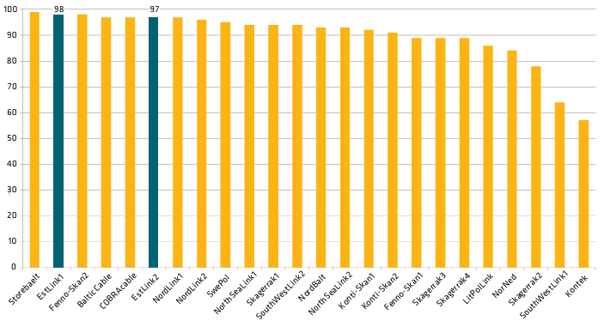
Figure 1: Transmission availability of Nordic and Baltic HVDC cables as a percentage of full capacity in 2023
However, the extended outages of ESTLINK 2 during 2024 and 2025 have demonstrated that this approach is not sustainable and revision of the LTSC is needed. For an illustration of the availability of ESTLINK 1 and ESTLINK 2 cables in 2014-2024, see the figures 2 and 3 below.

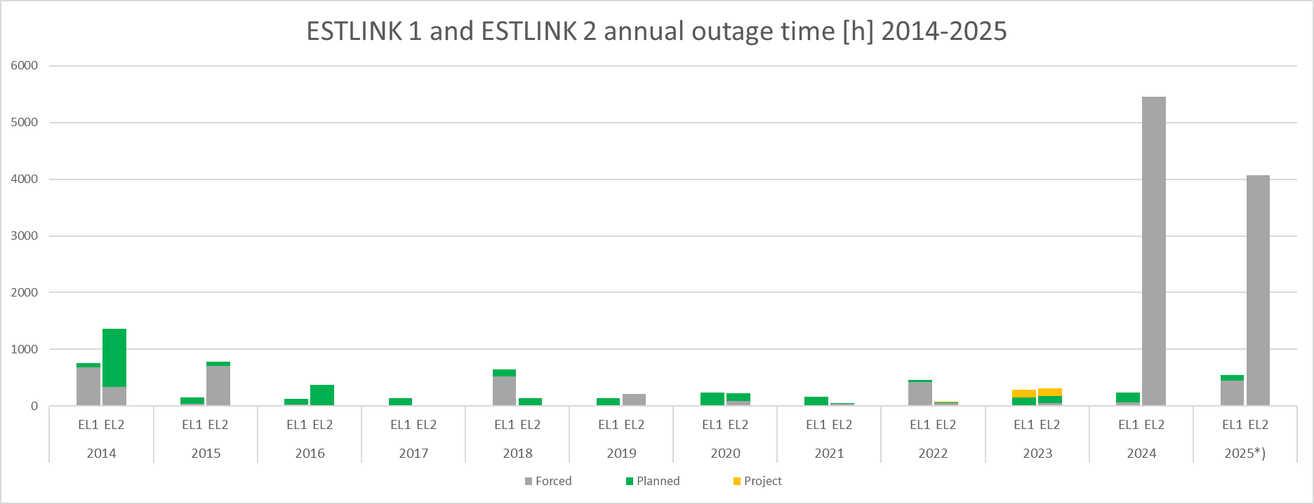
Figure 2: ESTLINK 1 and 2 annual outage time in hours 2014- 2025. *) NB. 2025 data up until early December 2025.
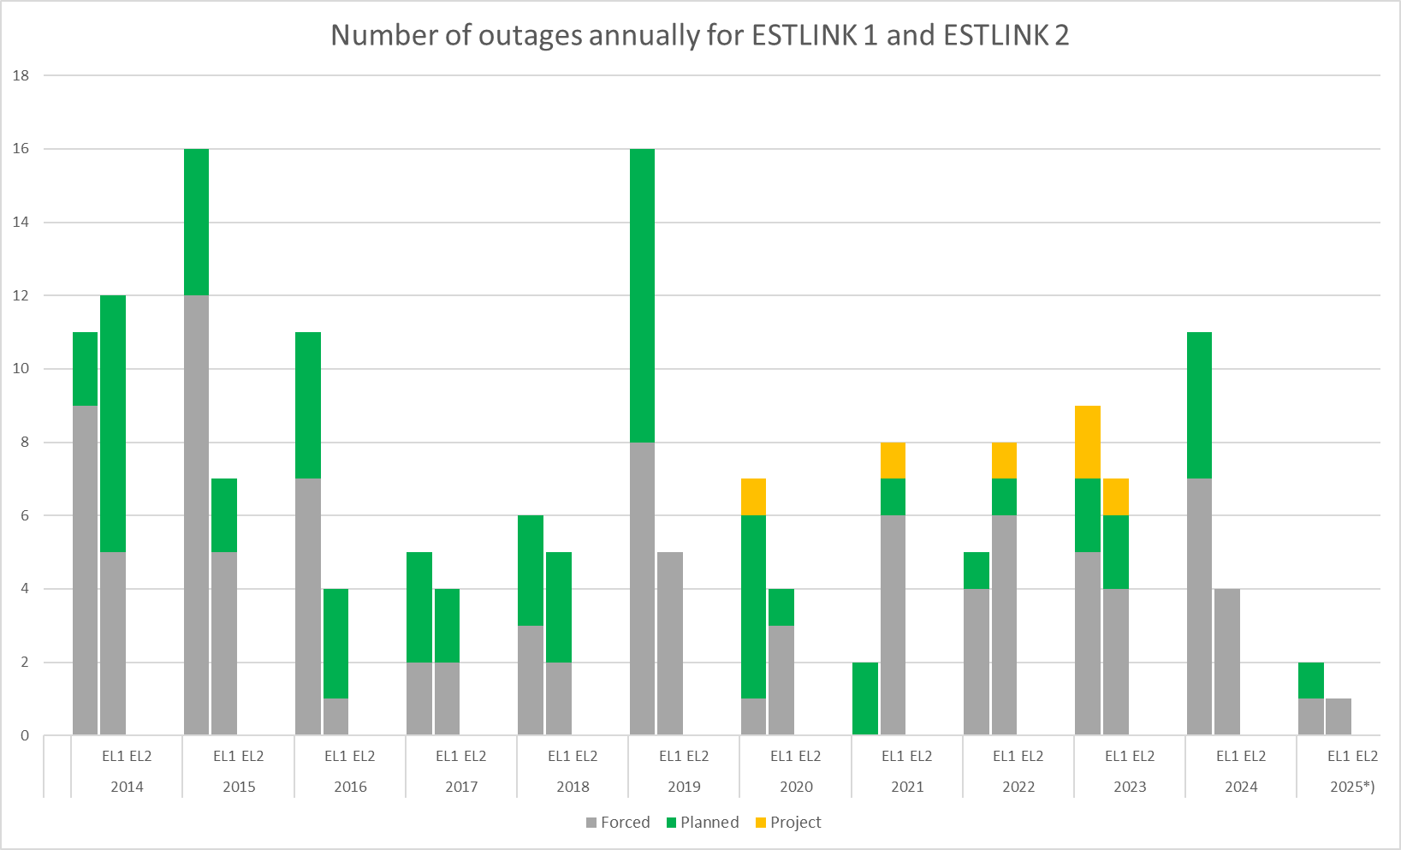
Figure 3: Number of outages annually 2014-25 for ESTLINK 1 and 2. *) NB. 2025 data up until early December 2025.
Elering and Fingrid are therefore proposing to limit the FI–EE LTTR volumes to reflect the observed availability of the ESTLINK 1 and ESTLINK 2 interconnectors as this influences the firmness of the FTRs
Considering the above, the TSOs propose that the sum of yearly and monthly LTTR volumes be limited to the maximum capacity of ESTLINK 1, i.e., 350 MW. By limiting the capacity to 350 MW, it is more likely that the capacity allocated for the LTTR auctions can be provided, if at least one of the ESTLINK interconnectors is in normal operational use. Seen from a historical perspective, it is highly unlikely that both ESTLINK interconnectors will be out of normal operation simultaneously.

4. Taking underselling into account
Underselling is defined as a situation where the marginal price of the LTTRs determined in the auction of LTTRs, for a given timeframe, is lower than the average day-ahead price spread between two bidding zones used as the reference price for settlement of the LTTRs. In other words, underselling in short means a situation where the buyer of the LTTR systematically obtains a higher cash flow from the variable settlement than what was paid by the buyer of the transmission right. In case of well-functioning competition, one should to some degree expect the auction price to be statistically distributed around the price spread. If underselling was present in a product, then with well-functioning competition it would be expected that new market participants enter the auctions and drive up the price until equilibrium is reached where no underselling is present. However, this is not what has been observed in the FI-EE LTTR auctions. Instead, the auction prices of the FI-EE LTTRs demonstrate a persistent pattern of underselling, as illustrated by table 1 and figure 4 below. Only months when both ESTLINK interconnectors have been in normal operation have been included in the table.

Table 1: Net income for TSO from LTTRs on FI-EE border
Month when ESTLINK 1 and 2 have been in normal operation | Net income for TSO from LTTRs on FI-EE border [€]
January 2023 | 1 069 890,51
February 2023 | -3 777 655,08
March 2023 | 1 227 633,50
April 2023 | 2 780 828,95
May 2023 | -5 659 272,13
June 2023 | -5 263 996,50
July 2023 | -6 833 659,51
August 2023 | -1 307 579,19
September 2023 | -13 515 124,25
October 2023 | -5 550 460,82
November 2023 | -1 399 471,26
December 2023 | 616 050,25
ESTLINK 2 outage 26.1.-2.9.2024
October 2024 | -5 506 394,75
November 2024 | -1 617 549,75
ESTLINK 2 outage 25.12.2024-19.6.2025
July 2025 | 4 054 424,38
August 2025 | -459 776,49
September 2025 | -3 724 773,50
October 2025 | -3 341 976,63
November 2025 | -4 476 080,5

Figure 4: TSO net income from FTRs on FI-EE for months when both ESTLINK interconnectors have been in operation.
Table 1 above presents the net income for TSOs from FI-EE LTTRs, calculated from the total auction income, reduced by the clearing and settlement of the LTTRs. The results imply underselling.
The impact of underselling materializes as a decrease of TSOs’ congestion income as TSOs effectively switch their congestion income from day-ahead market to the LTTR auction income. In case the LTTR auction income is systematically lower than the realized day-ahead price difference, the market participants obtaining the LTTR capacity are systematically benefiting at the expense of tariff payers. This is because less money will be available for the primary uses of congestion income including increasing and maintaining cross-zonal capacities, guaranteeing the availability of the allocated capacities, or for lowering grid tariffs.
To monitor underselling, TSOs use the public data from the auctions on the Single Allocation Platform (SAP) as input for calculating volumes for the LTTRs. Joint Allocation Office (JAO) is appointed as the SAP, according to the methodology developed under Article 48 of the FCA. Historical auction data, including all submitted bids and related prices, is available on JAO’s website.
After analysis the results of the FI-EE FTR auctions (Figure 5-6) in 2024 and 2025, it becomes evident that auction winners were often from areas other than the Baltic or Finnish markets. This might imply that the hedging needs of market participants in the Finnish and Baltic markets could potentially be satisfied with lower volumes of LTTRs than what is currently made available.

Figure 5: Trading of FTRs in EUR on the FI–EE bidding zone border by country in 2024 (Source: JAO).

Figure 6: Trading of FTRs in EUR on the FI–EE bidding zone border by country in 2025 (Source: JAO).

5. Transmission system operator’s increased financial risk

According to Article 35 of the FCA Regulation, the relevant TSOs allocating transmission rights must remunerate LTTRs holders in case the price difference is positive in the direction of the long-term transmission rights. In order to fulfil this remuneration obligation, TSOs rely on the congestion income. The FCA Regulation lays down rules on the firmness of allocated cross-zonal capacity in the forward markets.
- Article 53 of the FCA Regulation states under paragraph (1) that ‘All TSOs shall be entitled to curtail long-term transmission rights to ensure operation remains within operational security limits prior to the day-ahead firmness deadline. …’ Paragraph (2) of the same article further clarifies that ‘The concerned TSOs on the bidding zone border where long-term transmission rights have been curtailed shall compensate the holders of curtailed long-term transmission rights with the market spread.’
- Article 56 of the FCA Regulation states under paragraph (1) that ‘In the event of force majeure, TSOs may curtail long-term transmission rights. …’ Paragraph (3) of that article specifies that ‘In the event of curtailment due to force majeure the concerned holders of long-term transmission rights shall receive compensation for the period of that force majeure by the TSO which invoked the force majeure. In this case, the compensation shall be equal to the amount initially paid for the concerned long-term transmission right during the forward allocation process.’ Paragraph 4 of the same article states that ‘The TSO which invokes a force majeure shall make every possible effort to limit the consequences and duration of the force majeure.’
- Article 54 of the FCA Regulation addresses the possible definitions of caps for the compensation of curtailed LTTRs. More specifically, paragraph (1) of that article states that ‘The concerned TSOs on a bidding zone border may propose a cap on the total compensation to be paid to all holders of curtailed long-term transmission rights in the relevant calendar year or the relevant calendar month in case of Direct Current interconnectors.’ Paragraph (2) of the same article states that ‘The cap shall not be lower than the total amount of congestion income collected by the concerned TSOs on the bidding zone border in the relevant calendar year. In case of Direct Current interconnectors, TSOs may propose a cap not lower than the total congestion income collected by the concerned TSOs on the bidding zone border in the relevant calendar month.’
The Estonian and Finnish NRAs have approved a CAP for EE–FI FTRs in the “Baltic Capacity Calculation Region’s Regional Specific Annex to the Harmonised Allocation Rules for Long-Term Transmission Rights in accordance with Article 52 of Commission Regulation (EU) 2016/1719 of 26 September 2016 establishing a Guideline on Forward Capacity Allocation.” With this decision, the TSOs’ financial risk of paying remuneration in the event of a loss (or reduction below allocated FTR capacities) of day-ahead transmission capacity between Finland and Estonia — and the resulting loss of congestion income — is limited to the monthly collected congestion income.
However, there has been a significant increase in regulatory risk that the TSOs’ financial exposure may no longer be limited to congestion income. On 11 April 2025, ACER issued its legally non-binding public opinion, stating that:
- TSOs may curtail long-term transmission rights pursuant to Article 53(1) of Regulation (EU) 2016/1719, only if the allocated long-term transmission rights would endanger that operation of the transmission grid remains within operational security limits prior to the day-ahead firmness deadline. Since financial transmission rights on the FI-EE bidding zone border cannot have an impact on operational security, they should not be curtailed pursuant to Article 53(1) of Regulation (EU) 2016/1719.
- TSOs should not invoke force majeure unless all conditions specified in the definition of force majeure pursuant to Article 2(2)(u) of the harmonised allocation rules pursuant to Article 51 of Regulation (EU) 2016/1719 are met.
- The cap on the total compensation to be paid to all holders of curtailed long-term transmission rights applies only to the compensation for curtailments to ensure that operation remains within operational security limits before the day ahead firmness deadline in accordance with Article 59 of the harmonised allocation rules pursuant to Article 51 of Regulation (EU) 2016/1719. This cap does not apply to curtailments due to force majeure before the day ahead firmness deadline in accordance with Article 60 of the harmonised allocation rules pursuant to Article 51 of Regulation (EU) 2016/1719. Since financial transmission rights on the FI-EE bidding zone border should not be curtailed for operational security reasons in accordance with Article 53(1) of Regulation (EU) 2016/1719, a cap should not be applicable for that bidding zone border.
In October 2025, ENTSO-E published a common TSO position paper in which all TSOs expressed their disagreement with ACER’s Opinion 02/2025 regarding the curtailment of financial transmission rights and ACER’s interpretation of the overall regulatory framework applicable to LTTRs. If ACER’s Opinion were to be applied as written, interconnectors could face unlimited liabilities, significantly increasing TSOs’ financial risk exposure — especially considering recent developments in the risk environment related to energy infrastructure (such as the ESTLINK 2 incident).
On 24 November 2025, the Estonian NRA issued an injunction to Elering, officially prohibiting the curtailment of FTRs on the Estonian–Latvian bidding zone border, using the same reasoning as presented in ACER’s opinion.
Although Elering will challenge this injunction in court, until a court decision is reached, there remains a regulatory risk that the TSO’s financial exposure when offering FTRs would not be limited by congestion income. The inability to curtail FTRs could lead to excessive compensation obligations that may constrain the core tasks of TSOs, including the effective operation and expansion of the transmission system. This could also affect various stakeholders, including grid tariff payers. Moreover, increased financial risk for TSOs may negatively affect their credit rating, making grid expansion more expensive.
If Elering and Fingrid are not allowed to curtail FTRs, the price difference between Finland and Estonia, up to the volume of the sold FTRs, would have to be borne by Elering and Fingrid. The financial risk for Elering arising from ESTLINK outages with currently allocated FTR capacity limits is as follows:
- In the event of an ESTLINK 1 outage, the financial risk related to FTRs does not materialise, as approximately 650 MW of FTRs are sold in total, which can be covered with the capacity of ESTLINK 2.
- In the event of an ESTLINK 2 outage, the financial risk related to the monthly FTR product materialises, as the volume of the annual FTR can be covered with the capacity of ESTLINK 1. The size of the financial risk is shown in Figure 7 and depends on the price difference between Estonia and Finland. In recent ESTLINK 2 failures, the price difference has been around 50 €/MWh, resulting in an estimated financial risk of approximately €5 million for TSO.

Figure 7: TSOs cost in case of ESTLINK 1 or ESTLINK 1 and ESTLINK 2 outage
- In the event of a simultaneous ESTLINK 1 and ESTLINK 2 outage, the financial risk related to both the monthly and annual FTR products materialises. The risk for the monthly product is similar to the previous point, but higher due to the larger Finland–Estonia price difference when both ESTLINKs are out of service. The annual product risk is significantly higher because it lasts longer — until the end of the annual product or until one of the ESTLINKs is repaired. The size of the financial risk is shown in Figure 7 and depends on the price difference between Estonia and Finland. Assuming, for example, a 7-month repair period (based on past experience) and a 100 €/MWh price difference between Estonia and Finland (based on the modelled January–June 2025 price difference), cost per TSO would be approximately €100 million.
A simultaneous outage of both ESTLINKs is unlikely, but considering the geopolitical situation and recent incidents, it is by no means impossible. Considering the positions of ACER and the Estonian Competition Authority, the Finland–Estonia FTR must be viewed as a financial risk for TSOs. Since the funds used to compensate the FTR come from congestion income, the risk is primarily related to:
- the sufficiency of congestion income, and
- the potential lack of liquidity for TSO.
Congestion income accumulated in previous years may already have been used or committed at the moment the risk materialises. Therefore, when assessing the sufficiency of congestion income, it is reasonable to consider only the congestion income that would be additionally generated during the specific year. Based on previous years, an annual congestion income potential of €100 million can be considered reasonable on FI-EE border.
If the risk materialises, there would be a 7-month period during which FTRs must be compensated, meaning that the Finland–Estonia price difference would have to be covered from congestion income. This leaves a 5-month period for the collection of congestion income which could be used for FTR compensation. This corresponds to an estimated potential income of €42 million. Consequently, when selling FTRs, the volume must be limited so that the compensation costs do not exceed €42 million. As an example, assuming an average price difference of 100 €/MWh between Estonia and Finland during a simultaneous outage of both ESTLINKs, the allowable sales volume would be 150 MW of annual products and 150 MW of monthly products.
Based on the above considerations, the TSOs propose setting the FTR volumes at 200 MW for the annual product and the maximum of 150 MW for the monthly product. The inability to curtail FTRs could lead to excessive compensation obligations, limiting TSOs’ core tasks, affecting grid tariff payers, and potentially worsening TSOs’ credit ratings, thereby increasing the cost of grid development. Setting the FTR volumes at these levels ensures that even in the event of a simultaneous outage of both ESTLINKs, the compensation obligations remain within the expected annual congestion income, safeguarding TSO financial stability and ensuring compliance with Regulation (EU) 2019/943.
The following splitting shares of long-term cross-zonal capacity for FI-EE border shall be applied when allocating yearly and monthly shares of LTTRs capacity (in MW):

LTTR_{Y(n)} = min (minLTCZC_{Y(n)}; 200)

LTTR_{M(n)} = min (minLTCZC_{M(n)}– LTTR_{Y(n)}; 150)

Where:
LTTR_{Y(n)} – LTTRs capacity offered in yearly timeframe for year n in MW;
LTTR_{M(n)} – LTTRs capacity offered in relevant monthly timeframe for year n in MW;
minLTCZC_{Y(n)}– the minimum forecasted monthly NTC value in MW of the long-term cross-zonal capacity for respective border and respective year (n) calculated according to the Long-term CCM of Baltic CCR, as stated in FCA Regulation Article 10;
minLTCZC_{M(n)}– the minimum forecasted daily NTC value in MW of the long-term cross-zonal capacity for respective border and respective month n calculated according to the Long-term CCM of Baltic CCR, as stated in FCA Regulation Article 10.

6. Timeline
The methodology will be implemented from the first LTTR auction after the Baltic CCR NRAs has approved the LTCS or a decision has been taken by the Agency for the Cooperation of Energy Regulators in accordance with Article 4(9), Article 4(10) and Article (11) of the FCA Regulation regarding the methodology.

In the consultation phase, the proposed values were 150 MW for Yearly and 200 MW for Monthly products. However, taking into account the consultation feedback, amended to 200 MW to Yearly and 150 MW for Monthly products.
https://elering.ee/sites/default/files/public/varustuskindluse%20konverentsid/2024/Elering_VKA_2024_04062025.pdf (Figure 3.14)
https://eepublicdownloads.blob.core.windows.net/public-cdn-container/clean-documents/Network%20codes%20documents/NC%20FCA/publications/ENTSO-E_Advocacy_Paper_-_FTR_curtailment.pdf
Regulation (EU) 2019/943 of the European Parliament and of the Council on the internal market for electricity Article 19 – Use of congestion income According to this article, congestion income must be used exclusively for the following purposes: - Ensuring the availability and maintaining the operation of interconnectors; - Investments aimed at increasing interconnection capacity; - Or, if it cannot be used immediately, it must be placed on a separate account until it can be used for the purposes listed above.
In the consultation phase, the proposed values were 150 MW for Yearly and 200 MW for Monthly products. However, taking into account the consultation feedback, amended to 200 MW to Yearly and 150 MW for Monthly products.
In the consultation phase, the proposed values were 150 MW for Yearly and 200 MW for Monthly products. However, taking into account the consultation feedback, amended to 200 MW to Yearly and 150 MW for Monthly products.

