REGULATIONS
COMMISSION REGULATION (EU) 2016/1447
of 26 August 2016
establishing a network code on requirements for grid connection of high voltage direct current
systems and direct current-connected power park modules

Approved with Competition Authority Resolution No 7-26/2019-007 of 27 March 2019.

Applied as of 8 September 2019

TITLE II
GENERAL REQUIREMENTS FOR HVDC CONNECTIONS
CHAPTER 1
Requirements for active power control and frequency support
Article 11
Frequency ranges
1. An HVDC system shall be capable of staying connected to the network and remaining operable within the frequency ranges and time periods specified in Table 1, Annex I for the short circuit power range as specified in Article 32(2).
Frequency range | Time period for operation
47,0 Hz – 47,5 Hz | 60 seconds
47,5 Hz – 48,5 Hz | To be specified by each relevant TSO, but longer than established times for generation and  demand according to Regulation (EU) 2016/631 and Regulation (EU) 2016/1388 respectively, and longer than for DC-connected PPMs according to Article 39 from time intervals of 90 minutes
48,5 Hz – 49,0 Hz | To be specified by each relevant TSO, but longer than established times for generation and  demand according to Regulation (EU) 2016/631 and Regulation (EU) 2016/1388 respectively, and longer than for DC-connected PPMs according to Article 39 from time intervals of 90 minutes
49,0 Hz – 51,0 Hz | Unlimited
51,0 Hz – 51,5 Hz | To be specified by each relevant TSO, but longer than established times for generation and  demand according to Regulation (EU) 2016/631 and Regulation (EU) 2016/1388 respectively, and longer than for DC-connected PPMs according to Article 39 established intervals of 90 minutes
51,5 Hz – 52,0 Hz | To be specified by each relevant TSO, but longer than for DC-connected PPMs according to  Article 39 stipulated intervals of 15 minutes
Table 1: Minimum time periods an HVDC system shall be able to operate for different frequencies deviating from a nominal value without disconnecting from the network.
Explanation: The same values as for the power park modules with direct current connection in ANNEX IV, excl. the 47.0 – 47.5 Hz range.
3. Without prejudice to paragraph 1, an HVDC system shall be capable of automatic disconnection at frequencies specified by the relevant TSO.
Explanation: The specific frequency values will be determined on project basis.
4. The relevant TSO may specify a maximum admissible active power output reduction from its operating point if the system frequency falls below 49 Hz.
The maximum permitted reduction of output active power per frequency decrease of one Hz in the case of frequencies below 49 Hz is 2% of the maximum power at the frequency of 50 Hz.
Explanation: same as RfG Article 13.4.a.

Article 12
Rate-of-change-of-frequency withstand capability
An HVDC system shall be capable of staying connected to the network and operable if the network frequency changes at a rate between – 2,5 and + 2,5 Hz/s (measured at any point in time as an average of the rate of change of frequency for the previous 1 s).
RoCoF value +/-2.5 Hz/s.
Explanation: same value as in RfG and DCC.

Article 13
Active power controllability, control range and ramping rate
1. With regard to the capability of controlling the transmitted active power:
(a) an HVDC system shall be capable of adjusting the transmitted active power up to its maximum HVDC active power transmission capacity in each direction following an instruction from the relevant TSO.
The relevant TSO:
(i) may specify a maximum and minimum power step size for adjusting the transmitted active power;
(ii) may specify a minimum HVDC active power transmission capacity for each direction, below which active power transmission capability is not requested; and
(iii) shall specify the maximum delay within which the HVDC system shall be capable of adjusting the transmitted active power upon receipt of request from the relevant TSO.
The maximum delay during which the direct current transmission system should be able to set the transmitted active power after receiving the request from the respective TSO is 100 ms.
(b) the relevant TSO shall specify how an HVDC system shall be capable of modifying the transmitted active power infeed in case of disturbances into one or more of the AC networks to which it is connected. If the initial delay prior to the start of the change is greater than 10 milliseconds from receiving the triggering signal sent by the relevant TSO, it shall be reasonably justified by the HVDC system owner to the relevant TSO.
Explanation: Delay in the alarm mode no longer than 10 ms.
(c) the relevant TSO may specify that an HVDC system be capable of fast active power reversal. The power reversal shall be possible from the maximum active power transmission capacity in one direction to the maximum active power transmission capacity in the other direction as fast as technically feasible and reasonably justified by the HVDC system owner to the relevant TSOs if greater than 2 seconds.
The direct current transmission system must have the capability to change the direction of the active power as quickly as technically possible.
(d) for HVDC systems linking various control areas or synchronous areas, the HVDC system shall be equipped with control functions enabling the relevant TSOs to modify the transmitted active power for the purpose of cross-border balancing.
Explanation: the wording will remain the same.
2. An HVDC system shall be capable of adjusting the ramping rate of active power variations within its technical capabilities in accordance with instructions sent by relevant TSOs. In case of modification of active power according to points (b) and (c) of paragraph 1, there shall be no adjustment of ramping rate.
Explanation: the wording will remain the same. It must be possible to change the ramp rate from the control centre of the TSO.
3. If specified by a relevant TSO, in coordination with adjacent TSOs, the control functions of an HVDC system shall be capable of taking automatic remedial actions including, but not limited to, stopping the ramping and blocking FSM, LFSM-O, LFSM-U and frequency control. The triggering and blocking criteria shall be specified by relevant TSO and subject to notification to the regulatory authority. The modalities of that notification shall be determined in accordance with the applicable national regulatory framework.
Effects and blocking must proceed from voltage levels, frequency ranges and system overloads that deviate from the normal, and are specified on project-basis. Functionalities of higher priority must block functions of lower priority. For example: HVDC protection > special frequency effects (EPC) >automatic frequency and voltage regulation > normal work control orders.

Article 14
Synthetic inertia
1. If specified by a relevant TSO, an HVDC system shall be capable of providing synthetic inertia in response to frequency changes, activated in low and/or high frequency regimes by rapidly adjusting the active power injected to or withdrawn from the AC network in order to limit the rate of change of frequency. The requirement shall at least take account of the results of the studies undertaken by TSOs to identify if there is a need to set out minimum inertia.
The HVDC system must be able to create artificial intertia. The function must be integrated in the HVDC system. The specific parameters will be agreed on project basis.

Article 15
Requirements relating to frequency sensitive mode, limited frequency sensitive mode overfrequency and limited frequency sensitive mode underfrequency
Requirements applying to frequency sensitive mode, limited frequency sensitive mode overfrequency and limited frequency sensitive mode underfrequency shall be as set out in Annex II.

ANNEX II
A. Frequency sensitive mode
1. When operating in frequency sensitive mode (FSM):
(a) the HVDC system shall be capable of responding to frequency deviations in each connected AC network by adjusting the active power transmission as indicated in Figure 1 and in accordance with the parameters specified by each TSO within the ranges shown in Table 2. This specification shall be subject to notification to the regulatory authority. The modalities of that notification shall be determined in accordance with the applicable national regulatory framework;
(b) the adjustment of active power frequency response shall be limited by the minimum HVDC active power transmission capacity and maximum HVDC active power transmission capacity of the HVDC system (in each direction);
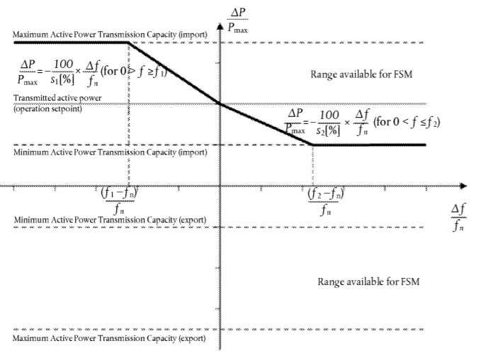
Figure 1: Active power frequency response capability of an HVDC system in FSM illustrating the case of zero deadband and insensitivity with a positive active power setpoint (import mode). ΔΡ is the change in active power output from the HVDC system. fn is the target frequency in the AC network where the FSM service is provided and Δf is the frequency deviation in the AC network where the FSM service is provided.
Parameters | Ranges
Frequency response deadband | configurable range 0 – ± 500 mHz
Droop s1 (upward regulation) | At least 0,1 % kuni 12%
Droop s2 (downward regulation) | At least 0,1 % kuni 12%
Frequency response insensitivity | 10 mHz
Table 2: Parameters for active power frequency response in FSM
(c) the HVDC system shall be capable, following an instruction from the relevant TSO, of adjusting the droops for upward and downward regulation, the frequency response deadband and the operational range of variation within the active power range available for FSM, set out in Figure 1 and more generally within the limits set by points (a) and (b). These values shall be subject to notification to the regulatory authority. The modalities of that notification shall be determined in accordance with the applicable national regulatory framework;
(d) as a result of a frequency step change, the HVDC system shall be capable of adjusting active power to the active power frequency response defined in Figure 1, in such a way that the response is:
(i) as fast as inherently technically feasible; and
(ii) at or above the solid line according to Figure 2 in accordance with the parameters specified by each relevant TSO within the ranges according to Table 3:
— the HVDC system shall be able to adjust active power output ΔΡ up to the limit of the active power range requested by the relevant TSO in accordance with the times t1 and t2 according to the ranges in Table 3, where t1 is the initial delay and t2 is the time for full activation. The values of t1 and t2 shall be specified by the relevant TSO, subject to notification to the regulatory authority. The modalities of that notification shall be determined in accordance with the applicable national regulatory framework;
— if the initial delay of activation is greater than 0,5 second, the HVDC system owner shall reasonably justify it to the relevant TSO.
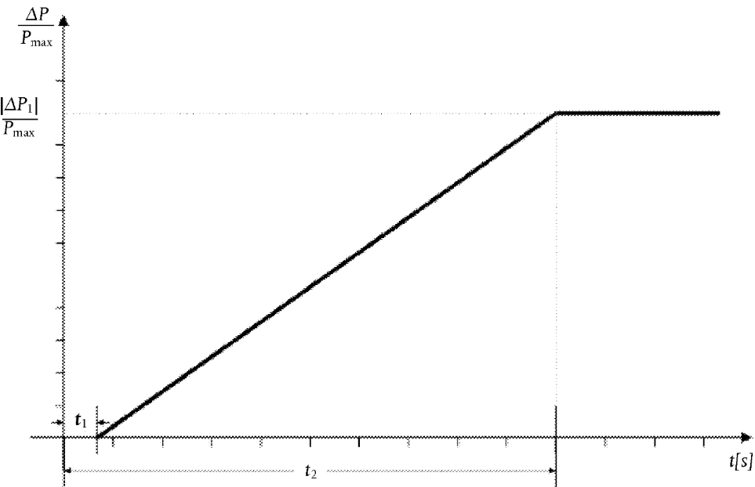
Figure 2: Active power frequency response capability of an HVDC system. ΔΡ is the change in active power triggered by the step change in frequency
Parameters | Time
Maximum admissible initial delay t1 | 0,5 seconds
Maximum admissible time for full activation t2, unless longer activation times are specified by the relevant TSO | 30 seconds
Table 3: Parameters for full activation of active power frequency response resulting from frequency step change.
Explanation: Same as the RfG frequency response parameters.
(e) for HVDC systems linking various control areas or synchronous areas, in frequency sensitive mode operation the HVDC system shall be capable of adjusting full active power frequency response at any time and for a continuous time period;
(f) as long as a frequency deviation continues active power control shall not have any adverse impact on the active power frequency response
B. Limited frequency sensitive mode overfrequency
1. In addition to the requirements of Article 11 the following shall apply with regard to limited frequency sensitive mode — overfrequency (LFSM-O):
(a) the HVDC system shall be capable of adjusting active power frequency response to the AC network or networks, during both import and export, according to Figure 3 at a frequency threshold f1 between and including 50,2 Hz and 50,5 Hz with a droop S3 adjustable from 0,1 % upwards;
Explanation: the wording will remain the same. In general, 50.2 Hz frequency and 5% droop.
(b) the HVDC system shall be capable of adjusting active power down to its minimum HVDC active power transmission capacity;
(c) the HVDC system shall be capable of adjusting active power frequency response as fast as inherently technically feasible, with an initial delay and time for full activation determined by the relevant TSO and notified to the regulatory authority in accordance with the applicable national regulatory framework;
(d) the HVDC system shall be capable of stable operation during LFSM-O operation. When LFSM-O is active, hierarchy of control functions shall be organised in accordance with Article 35.
2. The frequency threshold and droop settings referred to in point (a) of paragraph 1 shall be determined by the relevant TSO and be notified to the regulatory authority in accordance with the applicable national regulatory framework.
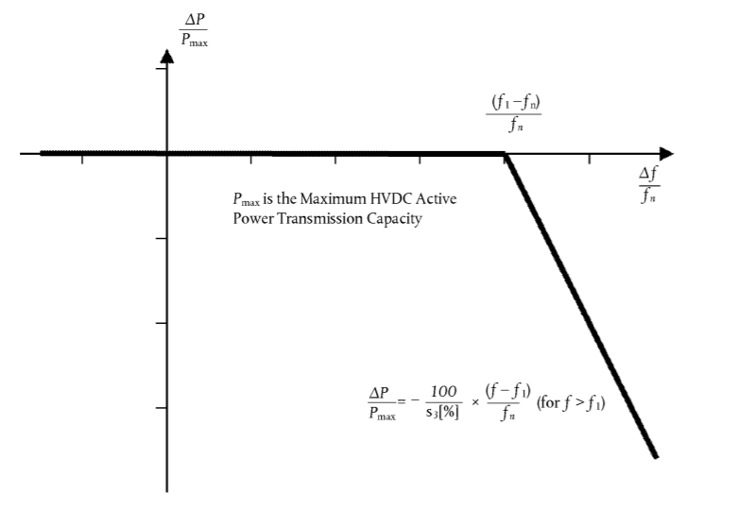
Figure 3: Active power frequency response capability of HVDC systems in LFSM-O. ΔΡ is the change in active power output from the HVDC system and, depending on the operational conditions, either a decrease of import power or an increase of export power. f n is the nominal frequency of the AC network or networks the HVDC system is connected to and Δf is the frequency change in the AC network or networks the HVDC is connected to. At overfrequencies where f is above f1 the HVDC system shall reduce active power according to the droop setting.
C. Limited frequency sensitive mode underfrequency 1. In addition to the requirements of Article 11, the following shall apply with regard to limited frequency sensitive mode — underfrequency (LFSM-U):
(a) the HVDC system shall be capable of adjusting active power frequency response to the AC network or networks, during both import and export, according to Figure 4 at a frequency threshold f2 between and including 49,8 Hz and 49,5 Hz with a droop S4 adjustable from 0,1 % upwards;
Explanation: the wording will remain the same. In general, 49.8 Hz frequency and 5% droop.
(b) in the LFSM-U mode the HVDC system shall be capable of adjusting active power up to its maximum HVDC active power transmission capacity;
(c) the active power frequency response shall be activated as fast as inherently technically feasible, with an initial delay and time for full activation determined by the relevant TSO and notified to regulatory authority in accordance with the applicable national regulatory framework;
(d) the HVDC system shall be capable of stable operation during LFSM-U operation. When LFSM-U is active, hierarchy of control functions shall be organised in accordance with Article 35.
2. The frequency threshold and droop settings referred to in point (a) of paragraph 1 shall be determined by the relevant TSO and be notified to the regulatory authority in accordance with the applicable national regulatory framework.
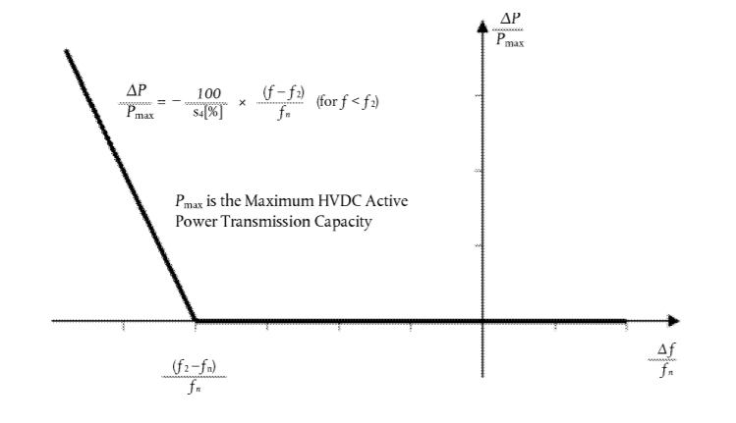
Figure 4: Active power frequency response capability of HVDC systems in LFSM-U. ΔΡ is the change in active power output from the HVDC system, depending on the operation condition a decrease of import power or an increase of export power. fn is the nominal frequency in the AC network or networks the HVDC system is connected and Δf is the frequency change in the AC network or networks the HVDC is connected. At underfrequencies where f is below f2, the HVDC system has to increase active power output according to the droop s4.

CHAPTER 2
Requirements for reactive power control and voltage support
Article 18
Voltage ranges
1. Without prejudice to Article 25, an HVDC converter station shall be capable of staying connected to the network and capable of operating at HVDC system maximum current, within the ranges of the network voltage at the connection point, expressed by the voltage at the connection point related to reference 1 pu voltage, and the time periods specified in Tables 4 and 5, Annex III. The establishment of the reference 1 pu voltage shall be subject to coordination between the adjacent relevant system operators.
ANNEX III
Synchronous Area | Voltage Range | Time period for operation
Baltic | 0,85 pu – 1,118 pu | Unlimited
Baltic | 1,118 pu – 1,15 pu | 20 minutes
Table 4: Minimum time periods an HVDC system shall be capable of operating for voltages deviating from the reference 1 pu value at the connection points without disconnecting from the network. This table applies in case of pu voltage base values at or above 110 kV and up to (not including) 300 kV.
Synchronous Area | Voltage Range | Time period for operation
Baltic | 0,88 pu – 1,097 pu | Unlimited
Baltic | 1,097 pu – 1,15 pu | 20 minutes
Table 5: Minimum time periods an HVDC system shall be capable of operating for voltages deviating from the reference 1 pu value at the connection points without disconnecting from the network. This table applies in case of pu voltage base values from 300 kV to 400 kV (included).
4. For connection points at reference 1 pu AC voltages not included in the scope set out in Annex III, the relevant system operator, in coordination with relevant TSOs, shall specify applicable requirements at the connection points.
5. Notwithstanding the provisions of paragraph 1, the relevant TSOs in the Baltic synchronous area may, following consultation with relevant neighbouring TSOs, require HVDC converter stations to remain connected to the 400 kV network in the voltage ranges and for time periods that apply in the Continental Europe synchronous area.

Article 19
Short circuit contribution during faults
1. If specified by the relevant system operator, in coordination with the relevant TSO, an HVDC system shall have the capability to provide fast fault current at a connection point in case of symmetrical (3-phase) faults.
2. Where an HVDC system is required to have the capability referred to in paragraph 1, the relevant system operator, in coordination with the relevant TSO, shall specify the following:
(a) how and when a voltage deviation is to be determined as well as the end of the voltage deviation;
(b) the characteristics of the fast fault current;
(c) the timing and accuracy of the fast fault current, which may include several stages.
Maximum delay for responding: 20 ms
90% of the changes must be achieved in 30 ms
Stabilisation time: 30 ms
Transient tolerance: -5%<∆x<+15%
Reactive power is preferred
100% fault current contribution to fault phase
The specific parameters of detecting faults will be agreed on project basis.
3. The relevant system operator, in coordination the relevant TSO, may specify a requirement for asymmetrical current injection in the case of asymmetrical (1-phase or 2-phase) faults.
100% fault current contribution to fault phase (according to previous point).

Article 20
Reactive power capability
1. The relevant system operator, in coordination with the relevant TSO, shall specify the reactive power capability requirements at the connection points, in the context of varying voltage. The proposal for those requirements shall include a U-Q/Pmax-profile, within the boundary of which the HVDC converter station shall be capable of providing reactive power at its maximum HVDC active power transmission capacity.
2. The U-Q/Pmax-profile referred to in paragraph 1 shall comply with the following principles:
(a) the U-Q/Pmax-profile shall not exceed the U-Q/Pmax-profile envelope represented by the inner envelope in the figure set out in Annex IV, and does not need to be rectangular;
(b) the dimensions of the U-Q/Pmax-profile envelope shall respect the values established for each synchronous area in the table set out in Annex IV; and
(c) the position of the U-Q/Pmax-profile envelope shall lie within the limits of the fixed outer envelope in the figure set out in Annex IV.

ANNEX IV
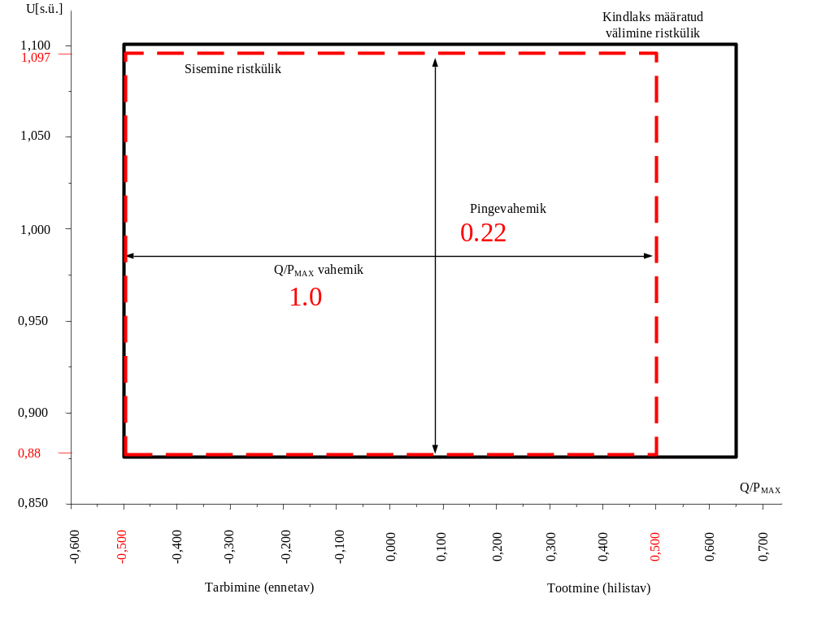
Determined outer rectangle
Inner rectangle
Voltage range
Q/P_{MAX} range
Figure 5: The diagram represents boundaries of a U-Q/Pmax-profile with U being the voltage at the connection points expressed by the ratio of its actual value to its reference 1 pu value in per unit, and Q/Pmax the ratio of the reactive power to the maximum HVDC active power transmission capacity. The position, size and shape of the inner envelope are indicative and shapes other than rectangular may be used within the inner envelope. For profile shapes other than rectangular, the voltage range represents the highest and lowest voltage points in this shape. Such a profile would not give rise to the full reactive power range being available across the range of steady-state voltages.
Synchronous Area | Maximum range of Q/Pmax | Maximum range of steady-state Voltage  level in PU
Baltic | 1,0 | 0,220
Table 6: Parameters for the Inner Envelope in the Figure.

3. An HVDC system shall be capable of moving to any operating point within its U-Q/Pmax profile in timescales specified by the relevant system operator in coordination with the relevant TSO.
The direct current transmission system must be able to move to any operation points on the U-Q/P_{max} schedule as fast as technically possible in the direct current system, but in no longer than 1 minute.
4. When operating at an active power output below the maximum HVDC active power transmission capacity (P < Pmax), the HVDC converter station shall be capable of operating in every possible operating point, as specified by the relevant system operator in coordination with the relevant TSO and in accordance with the reactive power capability set out by the U-Q/Pmax profile specified in paragraphs 1 to 3.

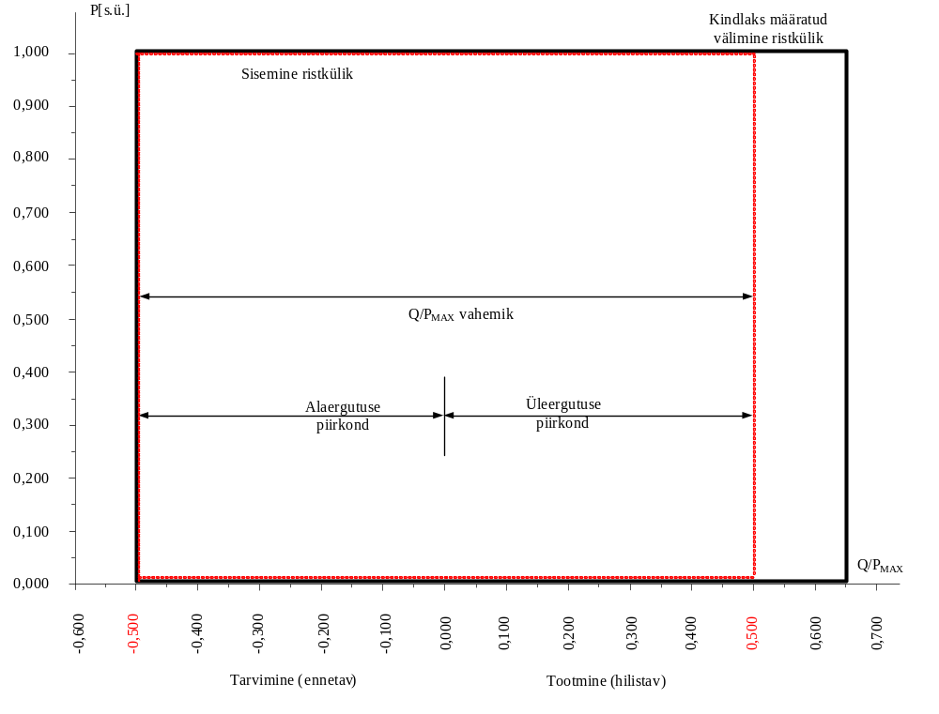
Determined outer rectangle
Inner rectangle
Q/P_{MAX} range
Under-excitation area
Over-excitation area
Consumption (pre-emptive)
Over-excitation area
Article 21
Reactive power exchanged with the Network
1. The HVDC system owner shall ensure that the reactive power of its HVDC converter station exchanged with the network at the connection point is limited to values specified by the relevant system operator in coordination with the relevant TSO.
Determined on project basis.
Explanation: Technology-specific requirement.
2. The reactive power variation caused by the reactive power control mode operation of the HVDC converter Station, referred to in Article 22(1), shall not result in a voltage step exceeding the allowed value at the connection point. The relevant system operator, in coordination with the relevant TSO, shall specify this maximum tolerable voltage step value
A frequency jump may not be bigger than 2% of the previous voltage value. Applied in the case of the smallest short-circuit power in a normal situation.

Article 22
Reactive power control mode
1. An HVDC converter station shall be capable of operating in one or more of the three following control modes, as specified by the relevant system operator in coordination with the relevant TSO:
(a) voltage control mode;
(b) reactive power control mode;
(c) power factor control mode.
Explanation: Voltage management and reactive power management functions are used in general.
2. An HVDC converter station shall be capable of operating in additional control modes specified by the relevant system operator in coordination with the relevant TSO.
3. For the purposes of voltage control mode, each HVDC converter station shall be capable of contributing to voltage control at the connection point utilising its capabilities, while respecting Articles 20 and 21, in accordance with the following control characteristics:
(a) a setpoint voltage at the connection point shall be specified to cover a specific operation range, either continuously or in steps, by the relevant system operator, in coordination with the relevant TSO;
The more exact operating range and regulation stages are determined on project-basis and the ordinary limits are given in the annex on the control signals of connection conditions.
(b) the voltage control may be operated with or without a deadband around the setpoint selectable in a range from zero to +/– 5 % of reference 1 pu network voltage. The deadband shall be adjustable in steps as specified by the relevant system operator in coordination with the relevant TSO;
The device is selected in the normal voltage range of the connection point and a dead zone is added around this value, which may be 0 to 5% of the value of the selected device. A small dead zone (minimum of 0%) is selected if the objective is to have more sensitive control and a bigger dead zone is – up to 5% – is selected if the voltage management system should interfere only in the case of larger voltage deviations. The values of the voltage configuration are determined in 1 kV steps. The dead band is determined with 1% steps.
(c) following a step change in voltage, the HVDC converter station shall be capable of:
(i) achieving 90 % of the change in reactive power output within a time t1 specified by the relevant system operator in coordination with the relevant TSO. The time t1 shall be in the range of 0,1-10 seconds; and
(ii) settling at the value specified by the operating slope within a time t2 specified by the relevant system operator in coordination with the relevant TSO. The time t2 shall be in the range of 1-60 seconds, with a specified steadystate tolerance given in % of the maximum reactive power.
Explanation: It must be possible to set T1 in the range of 0.1 to 10 seconds.
It must be possible to set T2 in the range of 1 to 60 seconds.
Accuracy 5% of maximum reactive power, but no more than 5 Mvar.
(d) voltage control mode shall include the capability to change reactive power output based on a combination of a modified setpoint voltage and an additional instructed reactive power component. The slope shall be specified by a range and step specified by the relevant system operator in coordination with the relevant TSO.
The voltage regulation droop is determined between 1–10%.
Explanation:
1% droop means:
* the entire reactive power reserve (100%) is used up in the case of a 1% voltage deviation.
* 50% of the reactive power reserve is used up in the case of a 0.5% voltage deviation.
10% droop means:
* 100% of the reactive power reserve is used up in the case of a 10% voltage deviation.
* 10% of the reactive power reserve is used up in the case of a 1% voltage deviation.
4. With regard to reactive power control mode, the relevant system operator shall specify a reactive power range in MVAr or in % of maximum reactive power, as well as its associated accuracy at the connection point, using the capabilities of the HVDC system, while respecting Articles 20 and 21.
The reactive power regulation range is in the total regulation capacity range (-0.5 r.u. to 0.5 r.u., calculated from nominal active power).
The regulation step is 1 MVAr.
5. For the purposes of power factor control mode, the HVDC converter station shall be capable of controlling the power factor to a target at the connection point, while respecting Articles 20 and 21. The available setpoints shall be available in steps no greater than a maximum allowed step specified by the relevant system operator.
Cos fi is generally not implemented. If cos fi is implemented, the permitted biggest step of the cos fi will be derived from the values given in Article 22(4).
6. The relevant system operator in coordination with the relevant TSO shall specify any equipment needed to enable the remote selection of control modes and relevant setpoints.
Explanation: Determined on project basis.

Article 24
Power quality
An HVDC system owner shall ensure that its HVDC system connection to the network does not result in a level of distortion or fluctuation of the supply voltage on the network, at the connection point, exceeding the level specified by the relevant system operator in coordination with the relevant TSO. The process for necessary studies to be conducted and relevant data to be provided by all grid users involved, as well as mitigating actions identified and implemented, shall be in accordance with the process in Article 29.
The permitted deformation levels for HVDC connections will be issued according to the established planning values of ER and they are assessed with studied in the cooperation simulation report. The planning values of the power quality of the voltage levels of the 110 kV and 330 kV transmission network are presented in the connection conditions.

CHAPTER 3
Requirements for fault ride through capability
Article 25
Fault ride through capability
1. The relevant TSO shall specify, while respecting Article 18, a voltage-against time profile as set out in Annex V and having regard to the voltage-against-time-profile specified for power park modules according to Regulation (EU) 2016/631. This profile shall apply at connection points for fault conditions, under which the HVDC converter station shall be capable of staying connected to the network and continuing stable operation after the power system has recovered following fault clearance. The voltage-against-time-profile shall express a lower limit of the actual course of the phase-to-phase voltages on the network voltage level at the connection point during a symmetrical fault, as a function of time before, during and after the fault. Any ride through period beyond trec2 shall be specified by the relevant TSO consistent with Article 18.

ANNEX V
Voltage-against-time-profile referred to in Article 25

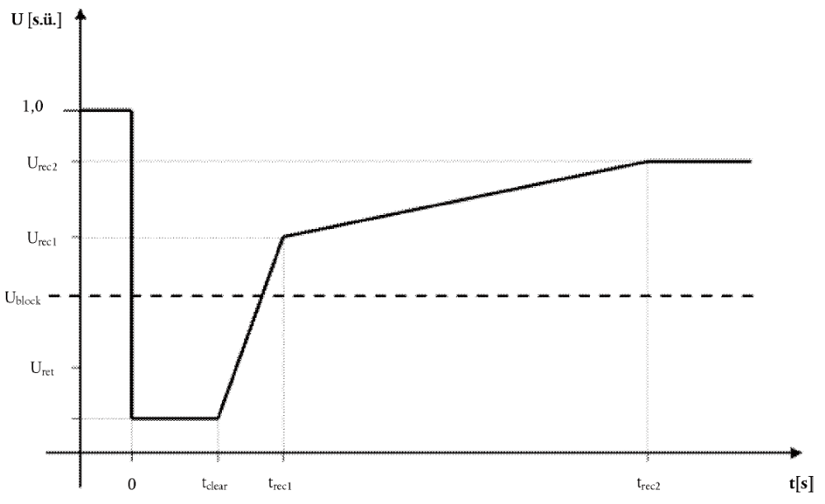
Figure 6: Fault-ride-through profile of an HVDC converter station. The diagram represents the lower limit of a voltageagainst-time profile at the connection point, expressed by the ratio of its actual value and its reference 1 pu value in per unit before, during and after a fault. Uret is the retained voltage at the connection point during a fault, tclear is the instant when the fault has been cleared, Urec1 and trec1 specify a point of lower limits of voltage recovery following fault clearance. Ublock is the blocking voltage at the connection point. The time values referred to are measured from tfault.
Voltage parameters [pu] |  | Time parameters [seconds]
U_{ret} | 0,00 | t_{clear} | 0,25
U_{rec1} | 0,85 | t_{rec1} | 1,5
U_{rec2} | 0,90 | t_{rec2} | 5
Table 7: Parameters for Figure 6 for the fault-ride-through capability of an HVDC converter station.

2. On request by the HVDC system owner, the relevant system operator shall provide the pre-fault and post-fault conditions as provided for in Article 32 regarding:
(a) pre-fault minimum short circuit capacity at each connection point expressed in MVA;
(b) pre-fault operating point of the HVDC converter station expressed as active power output and reactive power output at the connection point and voltage at the connection point; and
(c) post-fault minimum short circuit capacity at each connection point expressed in MVA.
Explanation: These values are given to the client with the connection contract.
3. The HVDC converter station shall be capable of staying connected to the network and continue stable operation when the actual course of the phase-to-phase voltages on the network voltage level at the connection point during a symmetrical fault, given the pre-fault and post-fault conditions provided for in Article 32, remain above the lower limit set out in the figure in Annex V, unless the protection scheme for internal faults requires the disconnection of the HVDC converter station from the network. The protection schemes and settings for internal faults shall be designed not to jeopardise fault-ride-through performance.
Explanation: The wording will not change.
4. The relevant TSO may specify voltages (Ublock) at the connection points under specific network conditions whereby the HVDC system is allowed to block. Blocking means remaining connected to the network with no active and reactive power contribution for a time frame that shall be as short as technically feasible and which shall be agreed between the relevant TSOs and the HVDC system owner.
Explanation: The TSO specifies the U_{block} value if the used technology does now allow for active and reactive current support in the case of near-zero network voltage. In this case, the U_{block} value proceeds from the technical capacity of the HVDC.
5. In accordance Article 34, undervoltage protection shall be set by the HVDC system owner to the widest possible technical capability of the HVDC converter station. The relevant system operator, in coordination with the relevant TSO, may specify narrower settings pursuant to Article 34.
The relay protection settings are approved on project basis.
6. The relevant TSO shall specify fault-ride-through capabilities in case of asymmetrical faults.
The same as in the case of symmetric short-circuits. ANNEX V Figure 6 and Table 7.

Article 26
Post fault active power recovery
The relevant TSO shall specify the magnitude and time profile of active power recovery that the HVDC system shall be capable of providing, in accordance with Article 25.
i) | Reactive power must be recovered after a fault no later than at the moment when the network tension achieves the level of 0.85 p.u.
ii) |  | Active power must be recovered without delay as fast as technically possible, but no later than 1s after the recovery of the network voltage.
iii) |  | The output power in comparison with the level before the fault may not decrease by more than 10% of the nominal active power.
Explanation: According to the requirements for RfG power park modules. RfG Article 20(3)(a).

Article 27
Fast recovery from DC faults
HVDC systems, including DC overhead lines, shall be capable of fast recovery from transient faults within the HVDC system. Details of this capability shall be subject to coordination and agreements on protection schemes and settings pursuant to Article 34.
Explanation: Agreed on project basis. Not less than Article 26: (1 s)

CHAPTER 4
Requirements for control
Article 28
Energisation and synchronisation of HVDC converter stations
Unless otherwise instructed by the relevant system operator, during the energisation or synchronisation of an HVDC converter station to the AC network or during the connection of an energised HVDC converter station to an HVDC system, the HVDC converter station shall have the capability to limit any voltage changes to a steady-state level specified by the relevant system operator in coordination with the relevant TSO. The level specified shall not exceed 5 per cent of the pre-synchronisation voltage. The relevant system operator, in coordination with the relevant TSO, shall specify the maximum magnitude, duration and measurement window of the voltage transients.
Upon steady-state operation in normal conditions:
|∆u| ≤ 2 % of nominal voltage
In the case of disturbed operation:
|∆u| ≤ 5 % of nominal voltage

Article 30
Power oscillation damping capability
The HVDC system shall be capable of contributing to the damping of power oscillations in connected AC networks. The control system of the HVDC system shall not reduce the damping of power oscillations. The relevant TSO shall specify a frequency range of oscillations that the control scheme shall positively damp and the network conditions when this occurs, at least accounting for any dynamic stability assessment studies undertaken by TSOs to identify the stability limits and potential stability problems in their transmission systems. The selection of the control parameter settings shall be agreed between the relevant TSO and the HVDC system owner.
The direct current transmission system must be able to dampen low-voltage oscillations in the 0.1–2 Hz frequency range.

TITLE III
REQUIREMENTS FOR DC-CONNECTED POWER PARK MODULES AND REMOTE-END HVDC CONVERTER STATIONS
CHAPTER 1
Requirements for DC-connected power park modules
Article 39
Frequency stability requirements
1. With regards to frequency response:
(a) a DC-connected power park module shall be capable of receiving a fast signal from a connection point in the synchronous area to which frequency response is being provided, and be able to process this signal within 0,1 second from sending to completion of processing the signal for activation of the response. Frequency shall be measured at the connection point in the synchronous area to which frequency response is being provided;
Explanation: The wording will not change.
2. With regard to frequency ranges and response:
(a) a DC-connected power park module shall be capable of staying connected to the remote-end HVDC converter station network and operating within the frequency ranges and time periods specified in Annex VI for the 50 Hz nominal system. Where a nominal frequency other than 50 Hz, or a frequency variable by design is used, subject to agreement with the relevant TSO, the applicable frequency ranges and time periods shall be specified by the relevant TSO taking into account specificities of the system and the requirements set out in Annex VI;
ANNEX VI
Frequency ranges and time periods referred to in Article 39(2)(a)
Frequency range | Time period for operation
47,0 Hz – 47,5 Hz | 20 sekundit
47,5 Hz – 49,0 Hz | 90 minutit
49,0 Hz – 51,0 Hz | Piiramata
51,0 Hz – 51,5 Hz | 90 minutit
51,5 Hz – 52,0 Hz | 15 minutit
Table 8: Minimum time periods for the 50 Hz nominal system for which a PPM shall be capable of operating for different frequencies deviating from a nominal value without disconnecting from the network.
3. With regards to rate-of-change-of-frequency withstand capability, a DC-connected power park module shall be capable of staying connected to the remote-end HVDC converter station network and operable if the system frequency changes at a rate up to +/– 2 Hz/s (measured at any point in time as an average of the rate of change of frequency for the previous 1 second) at the HVDC interface point of the DC-connected power park module at the remote end HVDC converter station for the 50 Hz nominal system.
Explanation: the wording will not change.
4. DC-connected power park modules shall have limited frequency sensitive mode — overfrequency (LFSM-O) capability in accordance with Article 13(2) of Regulation (EU) 2016/631, subject to fast signal response as specified in paragraph 1 for the 50 Hz nominal system.
The power park module with direct current connection must launch the frequency response of active power with the frequency level of 50.2 Hz and the droop parameter of 5%.
Explanation: Same as RfG Article 13.2.
5. A capability for DC-connected power park modules to maintain constant power shall be determined in accordance with Article 13(3) of Regulation (EU) 2016/631 for the 50 Hz nominal system.
Explanation: The wording will not change.
6. A capability for active power controllability of DC-connected power park modules shall be determined in accordance with Article 15(2)(a) of Regulation (EU) 2016/631 for the 50 Hz nominal system. Manual control shall be possible in the case that remote automatic control devices are out of service.
The power park module with direct current connection must comply with the requirements for power park modules stipulated in Article (15)(2)(a) of Directive (EU) 2016/631.
7. A capability for limited frequency sensitive mode — underfrequency (LFSM-U) for a DC-connected power park module shall be determined in accordance with Article 15(2)(c) of Regulation (EU) 2016/631, subject to fast signal response as specified in paragraph 1 for the 50 Hz nominal system.
A power park module with direct current connection must be able to launch output active power frequency response with the frequency limit and droop, which the respective TSO has determined as follows with the approval of the other TSOs in the same synchronous area:
— | the frequency limit determined by the TSO must be 49.8 Hz;
— | the droop determined by the TSO must be 5%.  8. A capability for frequency sensitive mode for a DC-connected power park module shall be determined in accordance with Article 15(2)(d) of Regulation (EU) 2016/631, subject to a fast signal response as specified in paragraph 1 for the 50 Hz nominal system.  The requirements for the frequency sensitive mode are the same as for generating modules in RfG.  9. A capability for frequency restoration for a DC-connected power park module shall be determined in accordance with Article 15(2)(e) of Regulation (EU) 2016/631 for the 50 Hz nominal system.  Explanation: the wording will not change.  10. Where a constant nominal frequency other than 50 Hz, a frequency variable by design or a DC system voltage is used, subject to the agreement of the relevant TSO, the capabilities listed in paragraphs 3 to 9 and the parameters associated with such capabilities shall be specified by the relevant TSO.  Article 40  Reactive power and voltage requirements  1. With respect to voltage ranges:  (a) a DC-connected power park module shall be capable of staying connected to the remote-end HVDC converter station network and operating within the voltage ranges (per unit), for the time periods specified in Tables 9 and 10, Annex VII. The applicable voltage range and time periods specified are selected based on the reference 1 pu voltage;  (b) wider voltage ranges or longer minimum times for operation can be agreed between the relevant system operator, the relevant TSO and the DC-connected power park module owner to ensure the best use of the technical capabilities of a DC-connected power park module if needed to preserve or to restore system security. If wider voltage ranges or longer minimum times for operation are economically and technically feasible, the DC-connected power park module owner shall not unreasonably withhold consent; 8.9.2016 EN Official Journal of the European Union L 241/21  (c) for DC-connected power park modules which have an HVDC interface point to the remote-end HVDC converter station network, the relevant system operator, in coordination with the relevant TSO may specify voltages at the HVDC interface point at which a DC-connected power park module shall be capable of automatic disconnection. The terms and settings for automatic disconnection shall be agreed between the relevant system operator, the relevant TSO and the DC-connected power park module owner;  (d) for HVDC interface points at AC voltages that are not included in the scope of Annex VII, the relevant system operator, in coordination with the relevant TSO shall specify applicable requirements at the connection point;  (e) where frequencies other than nominal 50 Hz are used, subject to relevant TSO agreement, the voltage ranges and time periods specified by the relevant system operator, in coordination with the relevant TSO, shall be proportional to those in Tables 9 and 10, Annex VII.  ANNEX VII  Voltage ranges and time periods referred to in Article 40
  Voltage Range | Time period for operation
  0,85 pu – 0,90 pu | 60 minutes
  0,90 pu – 1,10 pu | Unlimited
  1,10 pu – 1,118 pu | Unlimited
  1,118 pu – 1,15 pu | 20 minutes
Table 9: Minimum time periods for which a DC-connected power park module shall be capable of operating for different voltages deviating from a reference 1 pu value without disconnecting from the network where the voltage base for pu values is from 110 kV to (not including) 300 kV.

Voltage Range | Time period for operation
0,85 pu-0,90 pu | 60 minutes
0,90 pu-1,05 pu | Unlimited
1,05 pu -1,097 pu | Unlimited
1,097 pu – 1,15 pu | 20 minutes
Table 10: Minimum time periods for which a DC-connected power park module shall be capable of operating for different voltages deviating from a reference 1 pu value without disconnecting from the network where the voltage base for pu values is from 300 kV to 400 kV (included).
Explanation: same as in RfG.

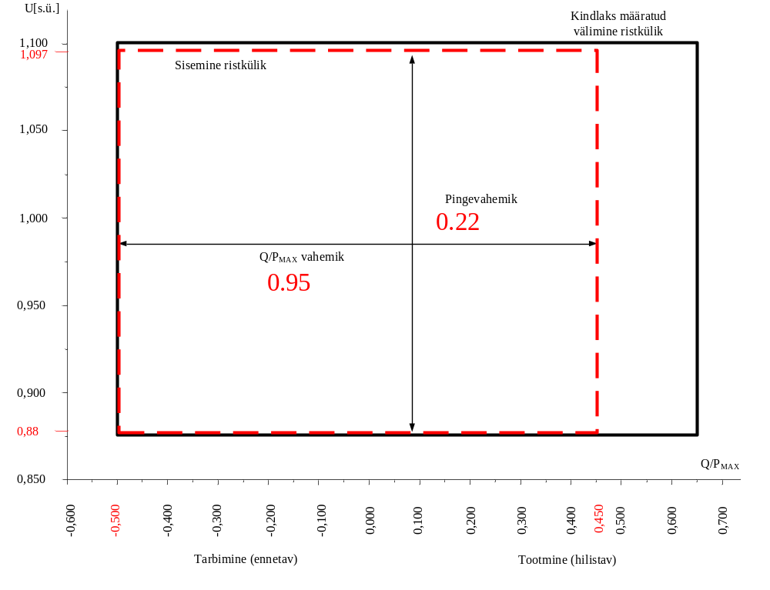
Determined outer rectangle
Inner rectangle
Voltage range
Q/P_{MAX} range
Consumption (pre-emptive)
Production (delaying)

Figure 7:U-Q/Pmax-profile of a DC-connected power park module at the connection point. The diagram represents boundaries of a U-Q/Pmax-profile of the voltage at the connection point[s], expressed by the ratio of its actual value to its reference 1 pu value in per unit, against the ratio of the reactive power (Q) to the maximum capacity (Pmax). The position, size and shape of the inner envelope are indicative and other than rectangular may be used within the inner envelope. For profile shapes other than rectangular, the voltage range represents the highest and lowest voltage points. Such a profile would not give rise to the full reactive power range being available across the range of steady-state voltages.

Range of width of Q/Pmax profile | Range of steady-state Voltage level in pu
0,95 (-0,5:0,45) | 0,22
Table 11: Maximum and minimum range of both Q/Pmax and steady-state voltage for a DC-connected PPM
Article 41
Control requirements
1. During the synchronisation of a DC-connected power park module to the AC collection network, the DCconnected power park module shall have the capability to limit any voltage changes to a steady-state level specified by the relevant system operator, in coordination with the relevant TSO. The level specified shall not exceed 5 per cent of the pre-synchronisation voltage. The relevant system operator, in coordination with the relevant TSO, shall specify the maximum magnitude, duration and measurement window of the voltage transients.
Upon steady-state operation in normal conditions:
|∆u| ≤ 2 % of nominal voltage
In the case of disturbed operation:
|∆u| ≤ 5 % of nominal voltage
2. The DC-connected power park module owner shall provide output signals as specified by the relevant system operator, in coordination with the relevant TSO.
Explanation: determined in the connection conditions.

Article 42
Network characteristics
With regard to the network characteristics, the following shall apply for the DC-connected power park modules:
(a) each relevant system operator shall specify and make publicly available the method and the pre-fault and post-fault conditions for the calculation of minimum and maximum short circuit power at the HVDC interface point;
(b) the DC-connected power park module shall be capable of stable operation within the minimum to maximum range of short circuit power and network characteristics of the HVDC interface point specified by the relevant system operator, in coordination with the relevant TSO;
(c) each relevant system operator and HVDC system owner shall provide the DC-connected power park module owner with network equivalents representing the system, enabling the DC-connected power park module owners to design their system with regard to harmonics;
Explanation: the network parameters will be provided in the course of the project.

Article 44
Power quality
DC-connected power park modules owners shall ensure that their connection to the network does not result in a level of distortion or fluctuation of the supply voltage on the network, at the connection point, exceeding the level specified by the relevant system operator, in coordination with the relevant TSO. The necessary contribution from grid users to associated studies, including, but not limited to, existing DC-connected power park modules and existing HVDC systems, shall not be unreasonably withheld. The process for necessary studies to be conducted and relevant data to be provided by all grid users involved, as well as mitigating actions identified and implemented, shall be in accordance with the process in Article 29.
The quality standards are given according to the ER planning values and the respective studies are carried out during the simulation of cooperation. Quality limits are calculated for each new client, which take into account the existing conditions, the nominal power of the new installation and the maximum capacity of the respective connection point.

Article 45
General system management requirements applicable to DC-connected power park modules
With regard to general system management requirements, Articles 14(5), 15(6) and 16(4) of Regulation (EU) 2016/631 shall apply to any DC-connected power park module.
Explanation: The wording will not change.

